

**COMSATS University Islamabad (CUI)**

**Assignment-02**

**CLO-2**

Software Requirement Specification  
(SRS DOCUMENT)

for

**Speech2Face**

Version 1.0

**Submitted By:**

**Shahzaneer Ahmed SP21-BCS-087**

**Shayan Zameer SP21-BCS-088**

**BCS-4-B**

***Supervisor*Mr. Tehseen Riaz Abbasi**

*\*

*Bachelor of Science in Computer Science (2021-2025)*

**Table of Contents**

1. Introduction 3

**1.1** **Purpose** 3

**1.2** **Scope** 3

**1.3** **Modules** 3

**1.3.1 Module 1: Profile Management** 3

**1.3.2 Module 2: Place Voice Record** 4

**1.3.3 Module 3: Sound to Face Vector Model** 4

**1.3.4 Module 4: Face-Vector to Face-Image Model** 4

**1.3.5 Module 5: Image View Customization** 4

**1.3.6 Module 6: Features Enhancer** 4

**1.3.7 Module 7: Insight Panel** 4

**1.3.8 Module 8: Feedback Panel** 5

**1.3. 9 Module 9: Help and Support** 5

**1.4** **Overview** 5

2. Overall Description 5

**2.1** **Product Perspective** 5

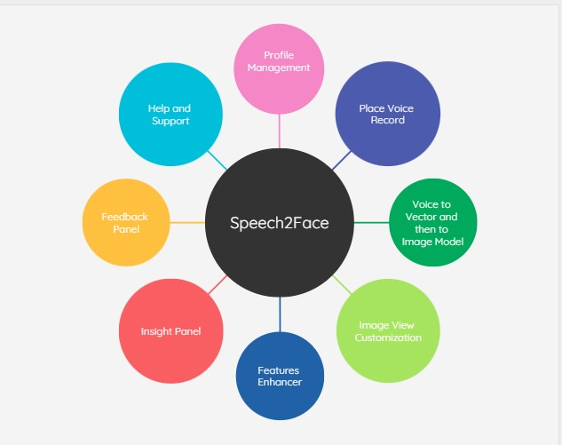 6

**2.2** **User classes and characteristics** 6

**2.3** **Operating Environment** 7

**2.4** **Design and Implementation Constraints** 7

3. Requirement Identifying Technique 7

**3.5.** **Use Case(s) Diagram:** 8

4. Functional Requirements 11

**4.1.** **Use Case(s) (List):** 11

**4.2.** **Use Case(s) (Tabular):** 13

**4.3.** **Functional Requirement X** 1

5. Non-Functional Requirements 37

**5.1** **Reliability** 37

**5.2** **) Usability** 38

**5.3** **) Performance** 38

**5.4** **) Security** 38

6. External Interface Requirements 38

**6.1)** **User Interfaces Requirements** 39

Mockups 40

**6.1** **Software interfaces** 41

**6.2** **Hardware interfaces** 41

**6.3** **Communications interfaces** 41

7. Conclusion 41

8. References 42

8.1) Related System: 42

▪ https://www.github.com/topics/sound-classification. 42

▪ https://speech2face.github.io/ 42

▪ Google Facenet 42

8.2) YouTube Resources: 42

• https://www.youtube.com/watch?v=aKYlSIs3UDY&t=334s 42

9. SRS Work Division 42

10. Plaragism Report 43

# 

# Introduction

The whole objective of this document is to cover all the details of **Speech2Face Application**. All the functionalities and requirements of the software are described in detail. The document contains all the description of the tasks that can be performed using the Application.

All the modules of the system are explained in detail. The functional and non-functional requirements of the system are provided in depth. This document will be useful for all the stakeholders involved in the project because it provides a comprehensive and in-depth information about the modules, function and non-functional requirements of the proposed system. The document will clearly describe what they would be able to do and what the system will not be able to do.

## **Purpose**

The purpose of this document is to allow all the stakeholders involved in the project to understand the parameters, complexities and goals of the Speech2Face. The stakeholders include developers, project managers, project supervisors, client, users, testers and document writers.

The document will make it easy to understand the requirements and the outcomes of the project. This document will allow the developers to differentiate between the functional and non-functional requirements of the project and it will also make the requirements clear which needs to be implemented by the developer Stake holders and are assured to be included by the specified clients.

## **Scope**

Speech2Face will be a Research and development-based Product with the main functionality to convert the voice into vector form and the vector form to image form and thus assisting in providing insights about the details of the person whose voice is under observation. It will be developed using different technologies and Deep Learning and machine learning techniques will be used. The Image generated can be modified in accordance with the users’ perspective.

***General user***: They can retrieve their images from their voice notes.

***Security Agencies***: It Can help them identify the criminals and speed up the process of resolving complex cases.

## **Modules**

## **1.3.1 Module 1: Profile Management**

**MF-1.1 Sign Up**

**MF-1.2 Login**

**MF-1.3 Sign in Via Phone**

**MF-1.4 Sign in as a Guest**

**MF-1.5 Sign in Via Voice**

**MF-1.6 Update Profile Information**

**MF-1.7 Delete Profile**

**MF-1.8 Logout**

## **1.3.2 Module 2: Place Voice Record**

**MF-2.1 Record Voice**

**MF-2.2 Upload Existing Voice**

**MF-2.3 Upload Existing Video to fetch Voice**

**MF-2.4 Update Voice**

**MF-2.5 Update Video**

**MF-2.6 Delete Voice**

**MF-2.7 Delete Video**

## **1.3.3 Module 3: Sound to Face Vector Model**

**MF-3.1 Sound to vector Modeling via Deep Learning**

**MF-3.2 Generate Vector Model**

## **1.3.4 Module 4: Face-Vector to Face-Image Model**

**MF-4.1 Vector to Image Modeling via Deep Learning**

**MF-4.2 Generate Image Model**

## **1.3.5 Module 5: Image View Customization**

**MF-5.1 Brightness Control**

**MF-5.2 Saturation Management**

**MF-5.3 Skin Color Management**

**MF-5.4 Filters**

## **1.3.6 Module 6: Features Enhancer**

**MF-6.1 Face Shape Enhancement**

**MF-6.2 Nose Enhancement**

**MF-6.3 Eyebrow Enhancement**

**MF-6.4 Beard Maker**

**MF-6.5 Eye Enhancement**

## **1.3.7 Module 7: Insight Panel**

**MF-7.1 View Report**

**MF-7.2 Download Report**

**MF-7.3 Share on Socials**

## **1.3.8 Module 8: Feedback Panel**

**MF-8.1 Rate Result**

**MF-8.2 Feedback in terms of words**

**MF-8.3 System Lagging Checks**

## **1.3. 9 Module 9: Help and Support**

**MF-9.1 Chat with AI Bot**

**MF-9.2 Contact Support Team**

**MF-9.3 Change Bots-Language**

**MF-9.4 View Bot’s Query History**

## **Overview**

The document contains all the useful frameworks and parameters of the Application Software. The document is organized in the following manner:

* The **Introduction** contains the purpose, scope and the modules of the Software.
* After the introduction, product perspective, operating environment and design/implementation constraints are defined.
* Subsequently, **use case** diagrams are used to describe use cases of our software.
* Then the functional and non-functional requirements of the software are described in depth.
* In the end, the external interface requirements like user, software, hardware, and communication interfaces are described in detail.

# Overall Description

Speech2face is a web and mobile application-based software that is mainly built to recognize the face general structure, ethnicity and gender with the audio waves. Currently there is

no full fledge software in the world that helps in this regard although there are deep learning libraries on which much work is done in the past. It was nearly impossible to predict the appearance of some person with his/her voice. But Artificial Intelligence has made it.

It will automate the attendance system and reinvigorate the authentication system as well.

## **Product Perspective**

The main idea of this project originated when the need of recognizing the facial features of the person from their voice arised. From the perspectives of a general user it is fun and overwhelming but from the perspective of any representative of Intelligence and security agencies it is highly benefitial. There are no realtime systems in the market which assists us in this regard.

## 

## **User classes and characteristics**

***Table 1: Actors and their Characteristics***

|  |  |
| --- | --- |
| **Character** | **Characteristics** |
| User | * The user can sign up/sign in via different ways. * The user can set up voice sign up as well. * Profile updation and deletion can be happened. * The Voice can be recorded, uploaded from pre-existing sources can be updated and deleted as well. * The voice can be transformed from Sound to vector Model * The vector model can be further transformed into Image Model * The image can be customized. * The user can share the image on socials. * Feedback can be given. * For System specifications they can chat with AI Bot and even contact the support team. |
| Security Agencies representative | * Along with other functionalities they can also Enhance the features of the image formed. * They can download Insight report in PDF format. |

## **Operating Environment**

* **Web Browsers:**

All versions of Google Chrome, Mozilla Firefox, Microsoft Edge, Opera and Apple Safari.

* **Operation Systems:**

Android versions 6 and above; and iOS versions 11 and above.

* **Geographical Location:**

The system mainly focuses all human beings being the R&D product.

* **Database and Website Hosting and Servers:**

Netlify will host our database and website. Nearest server locations of Netlify are located in Singapore and Amsterdam.

## **Design and Implementation Constraints**

Following are the system constraints:

* The System shall use already built top rated Machine and deep learning libraries which are trained over a vast data set.
* The application will require good internet connection.
* The application will not operate on Android versions lower than 6 and iOS version lower than 11.
* The system shall use the current Firebase standards.
* For recording voice notes the access to microphone should be provided

# Requirement Identifying Technique

Following requirements gathering techniques were implemented.

* 1. **Questionnaire and Surveys:** 
     1. A set of Questions were given to the public for their thoughts on application. Requirements for our system were extracted from these Questionnaires. Data was gathered for Improvement and best features that were to be included.
  2. **Group Discussion:** 
     1. Group discussions with public and group partner were held for gathering the information necessary for development of this application.
  3. **Studying Related Systems:** 
     1. Various related system was studied to improve the requirements and cope up with the problems of the users. Research was complete and adequate to add value to the users.
  4. **Observation:**
     1. Different types of people were observed in different cases to make the system more reliable to the user and help solve their main problems through the system.

## **Use Case(s) Diagram:**

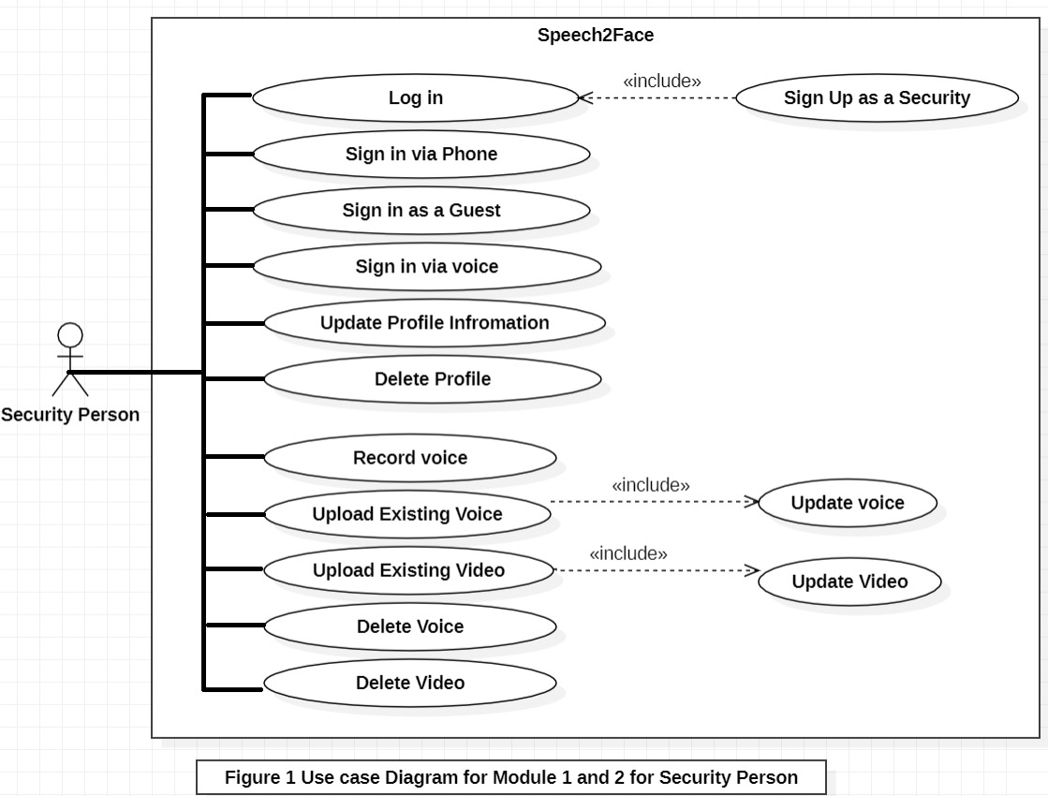

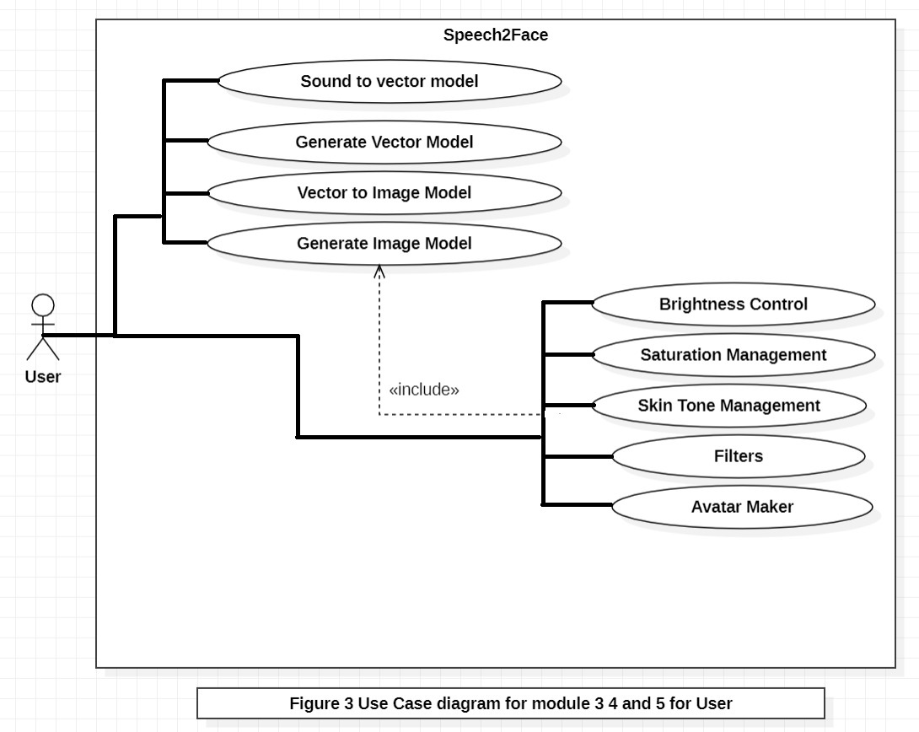

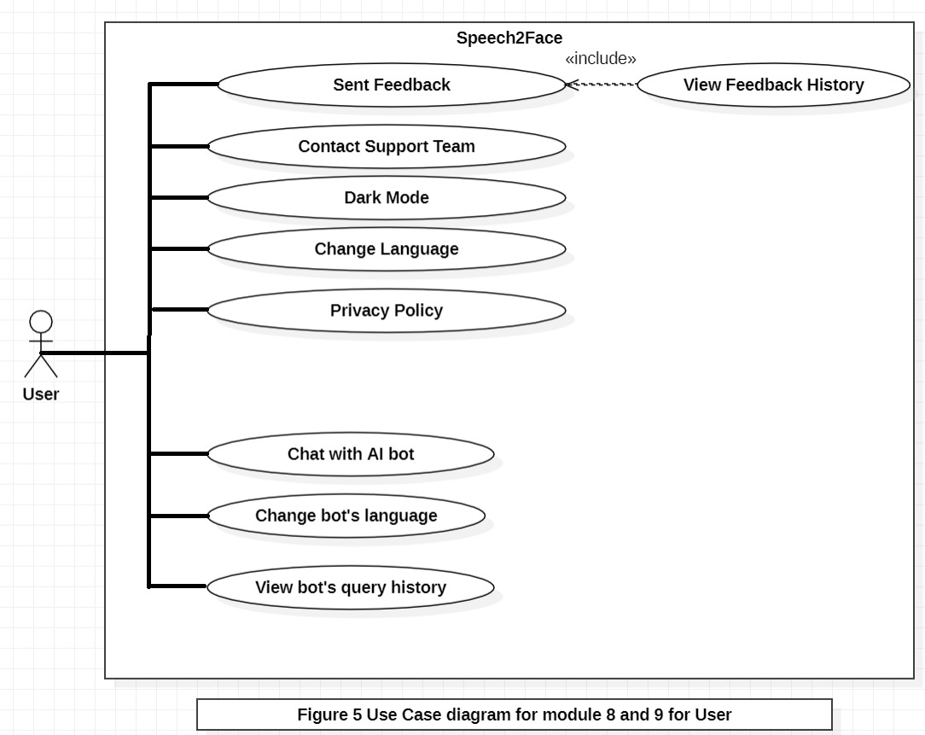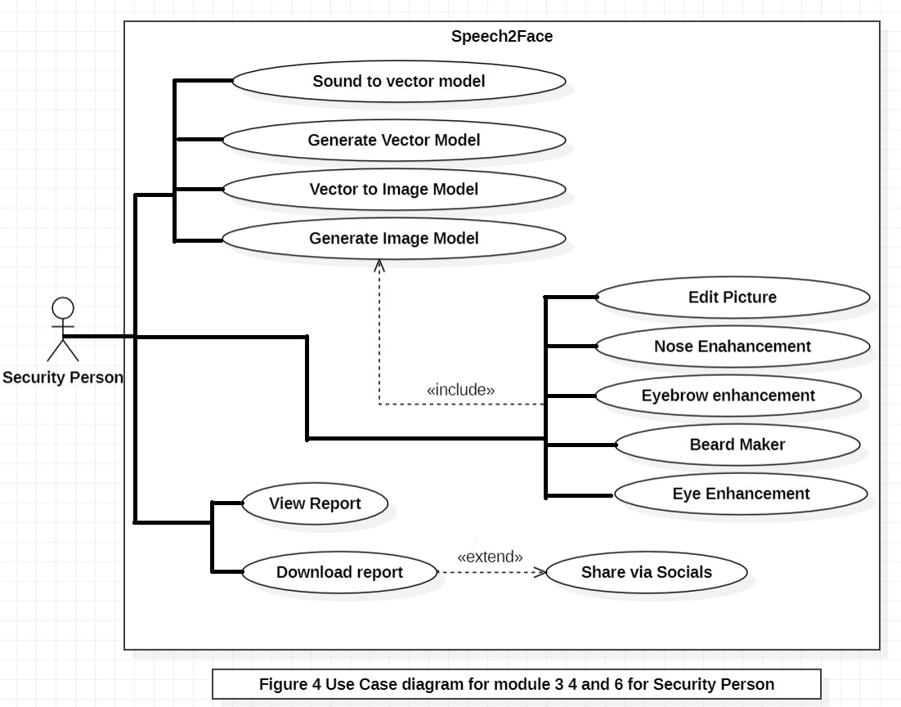

# Functional Requirements

This section focuses mainly on the

## **Use Case(s) (List):**

Create Use Case List as per module aspect. For Example:

#### Module 1: Profile Management

|  |  |
| --- | --- |
| **UC-ID** | **Use Case Name** |
| **UC-1.1** | Sign up |
| **UC-1.2** | Log in |
| **UC-1.3** | Sign in Via Phone |
| **UC-1.4** | Sign in Via Voice |
| **UC-1.5** | Update Profile |
| **UC-1.6** | Logout |

#### Module 3: Sound to Face Vector Model

|  |  |
| --- | --- |
| **UC-ID** | **Use Case Name** |
| **UC-3.1** | Sound to Vector Modeling Via Deep Learning |
| **UC-3.2** | Generate Vector Model |

#### Module 5: Image View Customization

|  |  |
| --- | --- |
| **UC-ID** | **Use Case Name** |
| **UC-5.1** | Brightness Control |
| **UC-5.2** | Saturation Management |
| **UC-5.3** | Skin Tone Management |
| **UC-5.4** | Filters |
| **UC-5.5** | Avatar Maker |

#### Module 7: Insight Panel

|  |  |
| --- | --- |
| **UC-ID** | **Use Case Name** |
| **UC-7.1** | View Report |
| **UC-7.2** | Download Report |
| **UC-7.3** | Share Via Socials |

#### Module 9: Help and Support

|  |  |
| --- | --- |
| **UC-ID** | **Use Case Name** |
| **UC-9.1** | Chat with AI Bot |
| **UC-9.2** | Contact with Support Team |
| **UC-9.3** | Change Bots’ Language |
| **UC-9.4** | View Bot’s Query History |

6

* ***Module 2: Place Voice Record***

|  |  |
| --- | --- |
| **UC-ID** | **Use Case Name** |
| **UC-2.1** | Record Voice |
| **UC-2.2** | Upload Existing Voice |
| **UC-2.3** | Upload Existing Video to Fetch Voice |
| **UC-2.4** | Update Voice |
| **UC-2.5** | Update Video |
| **UC-2.6** | Delete Voice |
| **UC-2.7** | Delete Video |

* ***Module 4: Face-Vector to Face-Image Model***

|  |  |
| --- | --- |
| **UC-ID** | **Use Case Name** |
| **UC-4.1** | Vector to Image Modeling via Deep Learning |

* ***Module 6: Features Enhancer***

|  |  |
| --- | --- |
| **UC-ID** | **Use Case Name** |
| **UC-6.1** | Edit Picture |
| **UC-6.2** | Nose Enhancement |
| **UC-6.3** | Eyebrow Enhancement |
| **UC-6.4** | Beard Maker |
| **UC-6.5** | Eye Enhancement |

* ***Module 8: Setting and Configuration***

|  |  |
| --- | --- |
| **UC-ID** | **Use Case Name** |
| **UC-8.1** | Sent Feedback |
| **UC-8.2** | Contact Support Team |
| **UC-8.3** | View Feedback History |
| **UC-8.4** | Dark Mode |
| **UC-8.5** | Change Language |
| **UC-8.6** | Privacy Policy |

## **Use Case(s) (Tabular):**

**Module 1: Profile Management**

1. **Sign Up**

|  |  |
| --- | --- |
| **Use Case ID:** | UC-1.1 |
| **Use Case Name:** | Sign Up |
| **Actors:** | User / Security agencies authority |
| **Description:** | User will create their account in order to use the application. |
| **Priority:** | High |
| **Precondition:** | User should have an authentic and valid email address and contact number. |
| **Trigger:** | User will click on the Sign-up button from main screen. |
| **Include:** | None. |
| **Normal Flow:** | 1. The user will enter authentic credentials (email, name, Voice) and password in the sign-up window. 2. Then user will click on the sign-up button. 3. OTP will be generated and sent to the user’s contact or email. 4. On correct input of OTP, successful sign-up message will be displayed to the user. |
| **Alternative Flows:** | None. |
| **Exceptions:** | * In step 4 of normal flow, if the user enters an invalid email address, and password:  1. An appropriate error message will be displayed 2. Asking the user to enter the data and credentials again 3. Then user will provide correct data.   Use Case resumes from step 5 of normal flow   * In step 7, if the user enters incorrect OTP:  1. An appropriate error message will be displayed. 2. User will be used to enter OTP again. 3. If fails to enter within 30 seconds, OTP will expire. 4. User will have to request another OTP and correctly enter it for successful sign-up. |
| **Post condition:** | After successful entry of credentials, new user account will be formed and control will move to home screen from where the user can log in or sign up. |
| **Business Rules:** | User should have a verified email address |
| **Notes & Issues:** | None. |
| **Assumptions:** | 1. User will have a stable internet connection. 2. User will be able to enter data correctly. |

1. **Log In**

|  |  |
| --- | --- |
| **Use Case ID:** | UC-1.2 |
| **Use Case Name:** | Log In |
| **Actors:** | User/ Security Agency Authority |
| **Description:** | User will log in to their account in order to use the application. |
| **Priority:** | High |
| **Precondition:** | User must have signed up for an account. |
| **Trigger:** | User will click on the Log-in button from main screen. |
| **Include:** | UC-1.1 |
| **Normal Flow:** | 1. The user will enter an authentic email and password used at the time of account creation in the login window. 2. Then user will click on the log in button. |
| **Alternative Flows:** | None. |
| **Exceptions:** | In step 1 of normal flow, if the user enters an invalid email address and password with which no account was formed:   1. An appropriate error message will be displayed 2. Asking the user to enter the credentials again 3. Then user will provide correct data.   Use Case resumes from step 2 of normal flow |
| **Post condition:** | After logging in, the user will reach to the main menu of the application from where they can see the main screen |
| **Business Rules:** | User should log in with correct email and password combination. |
| **Notes & Issues:** | None. |
| **Assumptions:** | 1. User will have a stable internet connection. 2. User will be able to enter data correctly. |

1. **Sign in Via Phone**

|  |  |
| --- | --- |
| **Use Case ID:** | UC-1.3 |
| **Use Case Name:** | Sign in Via Phone |
| **Actors:** | User/ Security Agency Authority |
| **Description:** | User will log in to their account in order to use the application. |
| **Priority:** | Medium |
| **Precondition:** | User must have signed up for an account. |
| **Trigger:** | User will click on the Log-in button from main screen. |
| **Include:** | UC-1.1 |
| **Normal Flow:** | * + - 1. Click the button Sign in via Phone. |
| **Alternative Flows:** | None. |
| **Exceptions:** | None |
| **Post condition:** | After logging in, the user will reach to the main menu of the application from where they can choose their role between renter and proprietor. |
| **Business Rules:** | None |
| **Notes & Issues:** | None. |
| **Assumptions:** | 1. User will have a stable internet connection. 2. User will be able to enter data correctly. |

1. **Sign in Via Voice**

|  |  |
| --- | --- |
| **Use Case ID:** | UC-1.4 |
| **Use Case Name:** | Sign in via Voice |
| **Actors:** | User |
| **Description:** | User will log in to their account in order to use the application. |
| **Priority:** | Medium |
| **Precondition:** | User must have signed up for an account. |
| **Trigger:** | User will click on the Log-in button from main screen. |
| **Include:** | UC-1.1 |
| **Normal Flow:** | 1.Click sign in via voice  2.Now the roller waiting symbol will appear for 30 secs and user should record the voice to get whole out of it. |
| **Alternative Flows:** | None. |
| **Exceptions:** | In step 1 of normal flow, if the user enters an invalid email address and voice with which no account was formed:   1. An appropriate error message will be displayed 2. Asking the user to enter the credentials again 3. Then user will provide correct data.   Use Case resumes from step 2 of normal flow |
| **Post condition:** | After logging in, the user will reach to the main menu of the application from where they can see the main screen. |
| **Business Rules:** | User should log in with correct email and Voice combination. |
| **Notes & Issues:** | None. |
| **Assumptions:** | 1. User will have a stable internet connection. 2. User will be able to enter data correctly. |

1. **Update Profile**

|  |  |
| --- | --- |
| **Use Case ID:** | UC-1.5 |
| **Use Case Name:** | Update Profile |
| **Actors:** | User |
| **Description:** | User can update info of their account. |
| **Priority:** | High |
| **Precondition:** | User must be logged in an account. |
| **Trigger:** | User will click on the edit profile button from side pane. |
| **Include:** | UC-1.2 |
| **Normal Flow:** | 1. The user can change/edit any detail of the given module including email , name,password, and voice record (for login) |
| **Alternative Flows:** | None. |
| **Exceptions:** | While logging out, if internet connection is lost the logging out process will be cancelled and user will be redirected to the main menu instead of the home screen. Use case resumes from step 1. |
| **Post condition:** | After successfully logging out, the user will be redirected to home screen from where they can sign up or log in again. |
| **Business Rules:** | User should have stable internet connection |
| **Notes & Issues:** | None. |
| **Assumptions:** | 1. User will have a stable internet connection. 2. User will be able to find and select the option from the menu correctly. |

1. **Logout**

|  |  |
| --- | --- |
| **Use Case ID:** | UC-1.6 |
| **Use Case Name:** | Log out |
| **Actors:** | User |
| **Description:** | User can log out from their account. |
| **Priority:** | High |
| **Precondition:** | User must be logged in an account. |
| **Trigger:** | User will click on the Log-out button from side pane. |
| **Include:** | UC-1.2 |
| **Normal Flow:** | 1. After using the application, the user wants to switch off their account. 2. From the main account settings, the user will click on the log out button. |
| **Alternative Flows:** | None. |
| **Exceptions:** | While logging out, if internet connection is lost the logging out process will be cancelled and user will be redirected to the main menu instead of the home screen. Use case resumes from step 1. |
| **Post condition:** | After successfully logging out, the user will be redirected to home screen from where they can sign up or log in again. |
| **Business Rules:** | User should have stable internet connection |
| **Notes & Issues:** | None. |
| **Assumptions:** | 1. User will have a stable internet connection. 2. User will be able to find and select the option from the menu correctly. |

**Module 3: Sound to Face Vector Model**

**3.1 Sound to Vector Modeling via Deep Learning**

|  |  |
| --- | --- |
| **Use Case ID:** | UC-3.1 |
| **Use Case Name:** | Sound to Vector Modeling via Deep Learning |
| **Actors:** | User and System |
| **Description:** | User the initiate the Deep Learning Module of converting the sound to vector model. |
| **Priority:** | Medium |
| **Preconditions:** | User must be logged in to their account. |
| **Trigger:** | The user will click on the “vector form” button. |
| **Include:** | UC-1.2 |
| **Normal Flow:** | 1. The DL library will start working on the voice and the user will have to wait for a minute or so. |
| **Alternative Flows:** | None. |
| **Exceptions:** | If the internet connection fails, the application will reload the loading process till it has been loaded. |
| **Post condition:** | None. |
| **Business Rules:** | User should have stable internet connection. |
| **Notes & Issues:** | None. |
| **Assumptions:** | 1. User will have a stable internet connection. 2. User will be able to find and select the option from the menu correctly. |

**3.2 Generate Vector Model**

|  |  |
| --- | --- |
| **Use Case ID:** | UC-3.2 |
| **Use Case Name:** | Generate Vector Model |
| **Actors:** | User |
| **Description:** | User can generate and view their vector pictures. |
| **Priority:** | Medium |
| **Preconditions:** | User must be logged in to their account. |
| **Trigger:** | The user will click on the display picture icon from the side pane. |
| **Include:** | UC-1.2 |
| **Normal Flow:** | 1. Three options will be provided. Whether view picture, upload picture from device or take a new picture. The user will select view picture. 2. The display picture will be opened. |
| **Alternative Flows:** | None. |
| **Exceptions:** | If the internet connection fails, the application will reload the display picture till it has been loaded. |
| **Post condition:** | View frame of profile picture will be opened. |
| **Business Rules:** | User should have stable internet connection. |
| **Notes & Issues:** | None. |
| **Assumptions:** | 1. User will have a stable internet connection. 2. User will be able to find and select the option from the menu correctly. |

**Module 5: Image View Customization**

**5.1 Brightness Control**

|  |  |
| --- | --- |
| **Use Case ID:** | UC-5.1 |
| **Use Case Name:** | Brightness Control |
| **Actors:** | User |
| **Description:** | User can control the brightness of image. |
| **Priority:** | Medium |
| **Preconditions:** | Image Should be formed beforehand via DL model. |
| **Trigger:** | The user will click on the brightness control tab and then the brightness screen will appear. |
| **Include:** | UC-4.2 |
| **Normal Flow:** | 1. The slider will be present to control the level of brightness.  2. There are two main ways to control via shadows and via brightness. |
| **Alternative Flows:** | None. |
| **Exceptions:** | None |
| **Post condition:** | The brightness of the image is customized. |
| **Business Rules:** | None |
| **Notes & Issues:** | None. |
| **Assumptions:** | 1. User will have a stable internet connection. 2. User will be able to find and select the option from the menu correctly. |

**5.2 Saturation Management**

|  |  |
| --- | --- |
| **Use Case ID:** | UC-5.2 |
| **Use Case Name:** | Saturation Management |
| **Actors:** | User |
| **Description:** | The saturation of the image can be managed in this module. |
| **Priority:** | Medium |
| **Preconditions:** | Image should be formed via the DL Model |
| **Trigger:** | The user will click on the saturation module and then the screen with the image will appear. |
| **Include:** | 4.2 |
| **Normal Flow:** | 1.The user will click on the three different categories provided by the module including hew, darkness and contrast and manage them by scrolling the slider. |
| **Alternative Flows:** | None. |
| **Exceptions:** | If the internet connection fails, the application will reload the display picture till it has been loaded. |
| **Post condition:** | The image with enhanced saturation will be available for the record. |
| **Business Rules:** | User should have stable internet connection. |
| **Notes & Issues:** | None. |
| **Assumptions:** | 1. User will have a stable internet connection. 2. User will be able to find and select the option from the menu correctly. |

**5.3 Skin Tone Management**

|  |  |
| --- | --- |
| **Use Case ID:** | UC-5.3 |
| **Use Case Name:** | Skin Tone Management |
| **Actors:** | User |
| **Description:** | User can modify the skin tone produced by the ML model according to his/her desire. |
| **Priority:** | Medium |
| **Preconditions:** | The Image should be already formed by the Image formation module. |
| **Trigger:** | The user will click on the skin tone enhancement button. |
| **Include:** | UC-4.2 |
| **Normal Flow:** | 1. The user will select the category of skin tones from given 5 options depending upon the preferred race  2.They can also change the intensity of color from mild to dark with the slider |
| **Alternative Flows:** | None. |
| **Exceptions:** | None. |
| **Post condition:** | The image with the preffered skin tone will be available for proceedings. |
| **Business Rules:** | User should have stable internet connection. |
| **Notes & Issues:** | None. |
| **Assumptions:** | 1.User will have a stable internet connection.  2.User will be able to find and select the option from the menu correctly. |

**5.4 Filters**

|  |  |
| --- | --- |
| **Use Case ID:** | UC-5.4 |
| **Use Case Name:** | Filters |
| **Actors:** | User |
| **Description:** | Users can apply filter to the images formed |
| **Priority:** | Medium |
| **Preconditions:** | The image should be formed beforehand. |
| **Trigger:** | The user will click on the Filters button |
| **Include:** | UC-4.2 |
| **Normal Flow:** | 1.The user can select the filters and select the one they like the most  2.Then they have to click the tick Icon to confirm the filter. |
| **Alternative Flows:** | None. |
| **Exceptions:** | If the internet connection fails, the application will reload the display picture till it has been loaded. |
| **Post condition:** | The image with filter will be available for the proceedings. |
| **Business Rules:** | User should have stable internet connection. |
| **Notes & Issues:** | None. |
| **Assumptions:** | 1.User will have a stable internet connection.  2.User will be able to find and select the option from the menu correctly. |

**5.5 Avatar Maker**

|  |  |
| --- | --- |
| **Use Case ID:** | UC-5.5 |
| **Use Case Name:** | Avatar Maker |
| **Actors:** | User |
| **Description:** | User can make their avatar and customize it. |
| **Priority:** | Medium |
| **Preconditions:** | The image should be formed before hand. |
| **Trigger:** | The user will click on the Create Avatar button. |
| **Include:** | UC-4.2 |
| **Normal Flow:** | 1. The avatar will be made from the image generated.  2.It can be Further customized. |
| **Alternative Flows:** | None. |
| **Exceptions:** | None. |
| **Post condition:** | None. |
| **Business Rules:** | User should have stable internet connection. |
| **Notes & Issues:** | None. |
| **Assumptions:** | 1. User will have a stable internet connection. 2. User will be able to find and select the option from the menu correctly. |

**Module 7: Insight Panel**

**7.1 View Report**

|  |  |
| --- | --- |
| **Use Case ID:** | UC-7.1 |
| **Use Case Name:** | Insight Panel |
| **Actors:** | User |
| **Description:** | User can view the report of their image generated. |
| **Priority:** | Medium |
| **Preconditions:** | The user must be logged in and should have generated some image via sound. |
| **Trigger:** | The user will click on the view report button. |
| **Include:** | UC-1.2 and UC-4.2 |
| **Normal Flow:** | 1.The user can view the report and generate it with different details. |
| **Alternative Flows:** | If internet is not present, the user will be prompt to check the connection and try again |
| **Exceptions:** | None. |
| **Post condition:** | The report will be generated. |
| **Business Rules:** | User should have stable internet connection. |
| **Notes & Issues:** | None. |
| **Assumptions:** | 1.User will have a stable internet connection.  2.User will be able to find and select the option from the menu correctly. |

**7.2 Download Report**

|  |  |
| --- | --- |
| **Use Case ID:** | UC-7.2 |
| **Use Case Name:** | Download Report |
| **Actors:** | User |
| **Description:** | User can download the report generated. |
| **Priority:** | Medium |
| **Preconditions:** | User must have generated the image. |
| **Trigger:** | The user will click on the display picture icon from the side pane. |
| **Include:** | UC-7.1 |
| **Normal Flow:** | 1.The user can download via PDF or export the JPG image format. |
| **Alternative Flows:** | None. |
| **Exceptions:** | If the internet connection fails, the application will not download instead it will show some error. |
| **Post condition:** | None. |
| **Business Rules:** | User should have stable internet connection. |

|  |  |
| --- | --- |
| **Notes & Issues:** | None. |
| **Assumptions:** | 1. User will have a stable internet connection. 2. User will be able to find and select the option from the menu correctly. |

**7.3 Share Via Socials**

|  |  |
| --- | --- |
| **Use Case ID:** | UC-7.3 |
| **Use Case Name:** | Share Via Socials |
| **Actors:** | Users |
| **Description:** | Users will be able to share reports on their social handles. |
| **Priority:** | Medium |
| **Preconditions:** | User must be logged in to their account. |
| **Trigger:** | The user will click on the social button, |
| **Include:** | UC-4.2 |
| **Normal Flow:** | 1.The user can share their reports or imagers generated on social media platforms. |
| **Alternative Flows:** | None. |
| **Exceptions:** | If the internet connection fails, the application will not be able to share rather it will prompt that there is no internet connection. |
| **Post condition:** | The image will be shared on socials. |
| **Business Rules:** | User should have stable internet connection. |
| **Notes & Issues:** | None. |
| **Assumptions:** | 1. User will have a stable internet connection. 2. User will be able to find and select the option from the menu correctly. |

**Module 9: Help and Support**

* 1. **Chat With AI Bot**

|  |  |
| --- | --- |
| **Use Case ID:** | UC-9.1 |
| **Use Case Name:** | Chat With AI Bot |
| **Actors:** | Users |
| **Description:** | The goal is to enable the users to chat with bot to get the automated answers of the AI Bot. |
| **Priority** | High |
| **Preconditions:** | 1. User must be logged into the application. 2. The user must select the FAQ option tab. |
| **Trigger** | When the user clicks the Bot at the lower section of the interface. |
| **Include** | None |
| **Normal Flow:** | 1. The user will open the web or mobile application 2. The user will sign into his/her account 3. After the home screen appears, move to the FAQ section. 4. The AI implemented bot will answer user’s queries. |
| **Alternative Flows:** | If the user is not connected to the internet, then he/she cannot chat with bot. |
| **Exceptions:** | None |
| **Post condition:** | The user will be able to chat with the bot. |
| **Business Rules:** | None |
| **Notes and Issues** | The bot might not answer the query if it is not fed into automated answers. |
| **Assumptions:** | 1. User must have a stable internet connection. 2. The user must understand the English language. 3. The user’s query exists in the answers fed into the bot. |

**9.2 Contact Support team**

|  |  |
| --- | --- |
| **Use Case ID:** | UC-9.2 |
| **Use Case Name:** | Contact Support Team |
| **Actors:** | User |
| **Description:** | User can contact the support team |
| **Priority:** | Medium |
| **Preconditions:** | User must be logged in to their account. |
| **Trigger:** | The user will click on contact support team option. |
| **Include:** | UC-1.2 |
| **Normal Flow:** | 1. The user will open the web or mobile application 2. The user will sign into his/her account 3. After the home screen appears, move to the FAQ section. 4. Then select Contact us option. |
| **Alternative Flows:** | None. |
| **Exceptions:** | None. |
| **Post condition:** | User can propose his/her problem to the support team and get it sorted out in 24 hours. |
| **Business Rules:** | User should have stable internet connection. |
| **Notes & Issues:** | None. |
| **Assumptions:** | 1.User will have a stable internet connection.  2.User will be able to find and select the option from the menu correctly. |

* 1. **Change Bot’s Language**

|  |  |
| --- | --- |
| **Use Case ID:** | UC-9.3 |

|  |  |
| --- | --- |
| **Use Case Name:** | Bot Language |
| **Actors:** | User |
| **Description:** | The goal is to enable the user to change the language |
| **Priority** | Low |
| **Preconditions:** | * + - 1. User must be logged into the application.       2. The user must go to the setting option to change the language. |
| **Trigger** | When the user clicks the change language button. |
| **Include** | None |
| **Normal Flow:** | 1. The user will open the web or mobile application 2. The user will sign into his/her account 3. After the home screen appears, move to the settings menu, then select the language option to select. |
| **Alternative Flows:** | None |
| **Exceptions:** | If the user is not connected to the internet, then bot’s language will not change. |
| **Post condition:** | The feedback would be sent to the management team which will help them make their application better and get notified about any bugs |
| **Business Rules:** | None |
| **Notes and Issues** | None |
| **Assumptions:** | 1. The user must understand the English language. 2. The user must be able to find the correct menu. |

**9.4 View Bot’s Query History**

|  |  |
| --- | --- |
| **Use Case ID:** | UC-9.4 |
| **Use Case Name:** | Bot’s Query |
| **Actors:** | User |
| **Description:** | User can see the Query History |
| **Priority:** | Low |
| **Preconditions:** | User must be logged in to their account and he should have some past queries. |
| **Trigger:** | The user will click on the view queires, |
| **Include:** | UC-1.2 |
| **Normal Flow:** | 1. User must be logged into the application. 2. The user must go to the help and support option to view the history. |
| **Alternative Flows:** | None. |
| **Exceptions:** | None. |

|  |  |
| --- | --- |
| **Post condition:** | The bot Query’s history will be projected. |
| **Business Rules:** | User should have stable internet connection. |
| **Notes & Issues:** | None. |
| **Assumptions:** | The user must understand the English language.  The user must be able to find the correct menu. |

#### Module 2: Place Voice Record

* **Record Voice**

|  |  |
| --- | --- |
| **Use Case ID:** | UC-2.1 |
| **Use Case Name:** | Record Voice |
| **Actors:** | User |
| **Description:** | The goal is to enable the users to record the voice which is then used for conversion of image of that person. |
| **Priority** | High |
| **Preconditions:** | * User must be logged into the application. |

|  |  |
| --- | --- |
| **Trigger** | The user will click convert button. |
| **Include** | UC-1.2 |
| **Normal Flow:** | * The user will open the web or mobile application * The user will sign into his/her account * After the home screen appears, move to the Add a voice option, then record voice. |
| **Alternative Flows:** | None |
| **Exceptions:** | * Microphone must be present in system to record a voice. |
| **Post condition:** | None |
| **Business Rules:** | None |
| **Notes and Issues** | None |
| **Assumptions:** | * The user must understand the English language. * The user must be able to find the correct menu. |

* **Upload Existing Voice**

|  |  |
| --- | --- |
| **Use Case ID:** | UC-2.2 |
| **Use Case Name:** | Upload Existing Voice |
| **Actors:** | Primary Actor: User  Secondary Actor: Security User |
| **Description:** | The goal is to enable the users to upload existing voice which is recorded previously by person. |
| **Priority** | High |
| **Preconditions:** | * Users must be logged into the application. |

|  |  |
| --- | --- |
| **Trigger** | The users will click convert button. |
| **Include** | UC-1.2 |
| **Normal Flow:** | * The users will open the web or mobile application * The users will sign into his/her account * After the home screen appears, move to the upload existing voice option, and then upload voice. |
| **Alternative Flows:** | * When user click upload existing option then two options appear: * Upload voice from Music folder or Upload voice from saved voices. |
| **Exceptions:** | None |
| **Post condition:** | None |
| **Business Rules:** | None |
| **Notes and Issues** | None |
| **Assumptions:** | * The user must understand the English language. * The user must be able to find the correct menu. |

* **Upload Existing Video to Fetch Voice**

|  |  |
| --- | --- |
| **Use Case ID:** | UC-2.3 |
| **Use Case Name:** | Upload Existing Video to Fetch Voice |
| **Actors:** | Primary Actor: User  Secondary Actor: Security User |
| **Description:** | The goal is to enable the users to upload existing video and voice is being extracted by video which is then converted to image. |
| **Priority** | High |
| **Preconditions:** | * User must be logged into the application. |
| **Trigger** | The user will click convert button. | |
| **Include** | UC-1.2 | |
| **Normal Flow:** | * The user will open the web or mobile application * The user will sign into his/her account * After the home screen appears, move to the upload existing video option, and then upload video. | |
| **Alternative Flows:** | * When user click upload existing option then two options appear: * Upload video from gallery or Upload video from saved videos. | |
| **Exceptions:** | None | |
| **Post condition:** | None | |
| **Business Rules:** | None | |
| **Notes and Issues** | None | |
| **Assumptions:** | * The user must understand the English language. * User must have a stable internet connection. * The user must be able to find the correct menu. | |

* **Update Voice**

|  |  |
| --- | --- |
| **Use Case ID:** | UC-2.4 |
| **Use Case Name:** | Update Voice |
| **Actors:** | Primary Actor: User  Secondary Actor: Security User |
| **Description:** | The goal is to enable the users to update voice which is recorded previously by person. |
| **Priority** | High |
| **Preconditions:** | * User must be logged into the application. * User must record voice at least one time. |

|  |  |
| --- | --- |
| **Trigger** | The user will click convert button. |
| **Include** | UC-2.1 |
| **Normal Flow:** | * The user will open the web or mobile application * The user will sign into his/her account * When user record voice then he/she has option to update voice by clicking update voice option. |
| **Alternative Flows:** | None |
| **Exceptions:** | None |
| **Post condition:** | * The user will again allow to record voice or upload voice. |
| **Business Rules:** | None |
| **Notes and Issues** | None |
| **Assumptions:** | * The user must understand the English language. * The user must be able to find the correct menu. * User must have a stable internet connection. * Microphone must be present in application. |

* **Update Video**

|  |  |
| --- | --- |
| **Use Case ID:** | UC-2.5 |
| **Use Case Name:** | Update Video |
| **Actors:** | Primary Actor: User  Secondary Actor: Security Person |
| **Description:** | The goal is to enable the users to provide facility to update video, which is previously uploaded by his/her. |
| **Priority** | High |
| **Preconditions:** | * User must be logged into the application. * User must upload video at least one time. |
| **Trigger** | The user will click convert button. | |
| **Include** | UC-2.3 | |
| **Normal Flow:** | * The user will open the web or mobile application * The user will sign into his/her account * When user upload video he/she has option to update video by clicking update video option. | |
| **Alternative Flows:** | * When user click update video option then two options appear: * Upload video from gallery or Upload video from saved videos. | |
| **Exceptions:** | None | |
| **Post condition:** | * The user will again allow to upload video. | |
| **Business Rules:** | None | |
| **Notes and Issues** | None | |
| **Assumptions:** | * The user must understand the English language. * User must have a stable internet connection. * The user must be able to find the correct menu. | |

* **Delete Voice**

|  |  |
| --- | --- |
| **Use Case ID:** | UC-2.6 |
| **Use Case Name:** | Delete Voice |
| **Actors:** | Primary Actor: User  Secondary Actor: Security Person |
| **Description:** | The goal is to enable the users to provide facility to delete saved voices. |
| **Priority** | High |
| **Preconditions:** | * User must be logged into the application. * User must have at least one saved voice. |
| **Trigger** | None. | |
| **Include** | UC-1.2 | |
| **Normal Flow:** | * The user will open the web or mobile application * The user will sign into his/her account * User will select saved voices option. * Then, User will delete voice which he/she wants. | |
| **Alternative Flows:** | None | |
| **Exceptions:** | None | |
| **Post condition:** | None | |
| **Business Rules:** | None | |
| **Notes and Issues** | None | |
| **Assumptions:** | * The user must understand the English language. * User must have a stable internet connection. * The user must be able to find the correct menu. | |

* **Delete Video**

|  |  |
| --- | --- |
| **Use Case ID:** | UC-2.7 |
| **Use Case Name:** | Delete Video |
| **Actors:** | Primary Actor: User  Secondary Actor: Security Person |
| **Description:** | The goal is to enable the users to provide facility to delete saved videos. |
| **Priority** | High |
| **Preconditions:** | * Users must be logged into the application. * Users must have at least one saved video. |
| **Trigger** | None. | |
| **Include** | UC-1.2 | |
| **Normal Flow:** | * The user will open the web or mobile application * The user will sign into his/her account * User will select saved videos option. * Then, User will delete video which he/she wants. | |
| **Alternative Flows:** | None | |
| **Exceptions:** | None | |
| **Post condition:** | None | |
| **Business Rules:** | None | |
| **Notes and Issues** | None | |
| **Assumptions:** | * The users must understand the English language. * Users must have a stable internet connection. * The users must be able to find the correct menu. | |

#### Module 4: Face Vector to Face Image Model

* **Vector to Image Modeling via Deep Learning**

|  |  |
| --- | --- |
| **Use Case ID:** | UC-4.1 |
| **Use Case Name:** | Vector to image Modeling via Deep Learning |
| **Actors:** | User |
| **Description:** | The goal is to enable the users to see how vector is converted to image using Machine learning. |
| **Priority** | High |
| **Preconditions:** | * Users must be logged into the application. * User must have stable internet connection. |

|  |  |
| --- | --- |
| **Trigger** | Convert image button plays role of trigger here. |
| **Include** | UC-1.2, UC-3.1 |
| **Normal Flow:** | * The user will open the web or mobile application * The user will sign into his/her account * When voice is converted to vector then * User enter convert image button to convert vector to image. |
| **Alternative Flows:** | None |
| **Exceptions:** | None |
| **Post condition:** | None |
| **Business Rules:** | None |
| **Notes and Issues** | None |
| **Assumptions:** | * The users must understand the English language. * Users must have a stable internet connection. * The users must be able to find the correct menu. |

#### Module 6: Features Enhancer

* **Face Shape Enhancement**

|  |  |
| --- | --- |
| **Use Case ID:** | UC-6.1 |
| **Use Case Name:** | Edit Picture |
| **Actors:** | Security Person |
| **Description:** | The goal is to enable the person to edit the face of person after generation of image model. |
| **Priority** | High |
| **Preconditions:** | * person must be logged into the application. |
|  | * The person must use place a voice option. * conversion of voice to image model is compulsory. |
| **Trigger** | None |
| **Include** | UC-4.2 |
| **Normal Flow:** | * The person will open the web or mobile application * The person will sign into his/her account * After the home screen appears, move to the Add a voice, then select conversion to image button. * After generation of image click edit button and select face enhancement option and enhance according to your need. |
| **Alternative Flows:** | None |
| **Exceptions:** | * If the user is not connected to the internet, then: * Conversion of image is not possible. * Face enhancement is also not possible. |
| **Post condition:** | None |
| **Business Rules:** | Person should have a stable internet connection. |
| **Notes and Issues** | None |
| **Assumptions:** | * Person must have a stable internet connection. * The Person must understand the English language. * The Person must be able to find the correct menu. |

* **Nose Enhancement**

|  |  |
| --- | --- |
| **Use Case ID:** | UC-6.2 |
| **Use Case Name:** | Nose Enhancement |
| **Actors:** | Security Person |
| **Description:** | The goal is to enable the person to enhance the Nose of person after generation of image model. |
| **Priority** | High |
| **Preconditions:** | * person must be logged into the application. |
|  | * The person must use place a voice option. * conversion of voice to image model is compulsory. |
| **Trigger** | None |
| **Include** | UC-4.2 |
| **Normal Flow:** | * The person will open the web or mobile application * The person will sign into his/her account * After the home screen appears, move to the Add a voice, then select conversion to image button. * After generation of image click edit button and select nose enhancement option and enhance according to your need. |
| **Alternative Flows:** | None |
| **Exceptions:** | * If the person is not connected to the internet, then: * Conversion of image is not possible. * Nose enhancement is also not possible. |
| **Post condition:** | None |
| **Business Rules:** | User should have a stable internet connection. |
| **Notes and Issues** | None |
| **Assumptions:** | * person must have a stable internet connection. * The person must understand the English language. * The person must be able to find the correct menu. |

* **Eyebrow Enhancement**

|  |  |
| --- | --- |
| **Use Case ID:** | UC-6.3 |
| **Use Case Name:** | Eyebrow Enhancement |
| **Actors:** | Security Person |
| **Description:** | The goal is to enable the person to enhance the Eyebrow of person after generation of image model. |
| **Priority** | High |
| **Preconditions:** | * person must be logged into the application. |

|  |  |
| --- | --- |
|  | * The Person must use place a voice option. * conversion of voice to image model is compulsory. |
| **Trigger** | None |
| **Include** | UC-4.2 |
| **Normal Flow:** | * The person will open the web or mobile application * The person will sign into his/her account * After the home screen appears, move to the Add a voice, then select conversion to image button. * After generation of image click edit button and select Eyebrow enhancement option and enhance according to your need. |
| **Alternative Flows:** | None |
| **Exceptions:** | * If the person is not connected to the internet, then: * Conversion of image is not possible. * Eyebrow enhancement is also not possible. |
| **Post condition:** | None |
| **Business Rules:** | User should have a stable internet connection. |
| **Notes and Issues** | None |
| **Assumptions:** | * person must have a stable internet connection. * The person must understand the English language. * The person must be able to find the correct menu. |

* **Beard Maker**

|  |  |
| --- | --- |
| **Use Case ID:** | UC-6.4 |
| **Use Case Name:** | Beard Maker |
| **Actors:** | Security Person |
| **Description:** | The goal is to enable the person to make the beard of person after generation of image model. |
| **Priority** | High |
| **Preconditions:** | * Person must be logged into the application. |

|  |  |
| --- | --- |
|  | * The person must use place a voice option. * conversion of voice to image model is compulsory. |
| **Trigger** | None |
| **Include** | UC-4.2 |
| **Normal Flow:** | * The person will open the web or mobile application * The person will sign into his/her account * After the home screen appears, move to the Add a voice, then select conversion to image button. * After generation of image click edit button and select beard option and make according to your need. |
| **Alternative Flows:** | None |
| **Exceptions:** | * If the perosn is not connected to the internet, then: * Conversion of image is not possible. * Making of beard is also not possible. |
| **Post condition:** | None |
| **Business Rules:** | person should have a stable internet connection. |
| **Notes and Issues** | None |
| **Assumptions:** | * User must have a stable internet connection. * The user must understand the English language. * The user must be able to find the correct menu. |

#### Module 8: Feedback Panel

* **Send Feedback**

|  |  |
| --- | --- |
| **Use Case ID:** | UC-8.1 |
| **Use Case Name:** | Send Feedback |
| **Actors:** | User |
| **Description:** | The goal is to enable the users to send feedback to the management team about the app. |
| **Priority** | High |
| **Preconditions:** | 1. User must be logged into the application. |
|  | 2. The user must select the feedback option available in the interface of the app. |
| **Trigger** | When the user wants to send the feedback. |
| **Include** | None. |
| **Normal Flow:** | * The user will open the web or mobile application * The user will sign into his/her account * After the home screen appears, move to the feedback section, then select the feedback option to add description. * The user can also rate the app while sending feedback. |
| **Alternative Flows:** | None |
| **Exceptions:** | * If the user is not connected to the internet, then: * The feedback will be failed to be sent. * The feedback might reload if the internet facility comes back. * The feedback is blank. * No rating star is selected. |
| **Post condition:** | The feedback would be sent to the management team which will help them make their application better and get notified about any bugs |
| **Business Rules:** | User should have a stable internet connection. |
| **Notes and Issues** | None |
| **Assumptions:** | * User must have a stable internet connection. * The user must understand the English language. * The user must be able to find the correct menu. |

* **Contact Support Team**

|  |  |
| --- | --- |
| **Use Case ID:** | UC-8.2 |
| **Use Case Name:** | Contact Support Team |
| **Actors:** | User |
| **Description:** | The goal is to enable the users to chat with the support team by sending a message. |
| **Priority** | Low |
| **Preconditions:** | User must be logged into the application. |
| **Trigger** | When the user clicks the Contact Us option provided in the interface. |
| **Include** | None. |
| **Normal Flow:** | 1. The user will open the web or mobile application 2. The user will sign into his/her account 3. After the home screen appears, move to the FAQ section. 4. Then select Contact us option. |
| **Alternative Flows:** | The user can directly contact the support team through email if he/she knows the email address of the support team. |
| **Exceptions:** | 1. If the user is not connected to the internet, then: 2. The message will be failed to send. 3. The message might reload if the internet facility comes back. 4. The message is blank. |
| **Post condition:** | The message will be sent to the management team and the query will be answered within 3-4 hours. |
| **Business Rules:** | User should have a stable internet connection. |
| **Notes and Issues** | None |
| **Assumptions:** | 1. User must have a stable internet connection. 2. The user must understand the English language. 3. The user must be able to find the correct menu. |

* **View Feedback History**

|  |  |
| --- | --- |
| **Use Case ID:** | UC-8.3 |
| **Use Case Name:** | View Feedback History |
| **Actors:** | User |
| **Description:** | The user can view the history of the feedbacks provided. |
| **Priority** | Low |
| **Preconditions:** | 1. User must be logged into the application. 2. The user must go to the help and support option to view the feedback history. |
| **Trigger** | When the user clicks the view history button. |
| **Include** | None |
| **Normal Flow:** | None |
| **Alternative Flows:** | None |
| **Exceptions:** | The user must be connected to the internet otherwise the page will fail to load and  move to the previous menu. |
| **Post condition:** | The user will be able to view the history of the feedbacks given by the user. |
| **Business Rules:** | None |
| **Notes and Issues** | None. |
| **Assumptions:** | 1. The user must understand the English language. 2. The user must be able to find the correct menu. |

* **Dark Mode**

|  |  |
| --- | --- |
| **Use Case ID:** | UC-8.4 |
| **Use Case Name:** | Dark Mode |
| **Actors:** | User |
| **Description:** | The user can switch the mode of application. |
| **Priority** | Medium |
| **Preconditions:** | User must be logged into the application with active internet connection |
| **Trigger** | When the user clicks the view history button. |
| **Include** | UC-1.2 |
| **Normal Flow:** | User will click on Dark mode button and click on the check to on it and then the system will apply dark mode to application |
| **Alternative Flows:** | None |
| **Exceptions:** | The user must be connected to the internet. |
| **Post condition:** | Dark mode will apply to the application. |
| **Business Rules:** | None |
| **Notes and Issues** | None. |
| **Assumptions:** | 1. The user must understand the English language. 2. The user must be able to find the correct menu. |

* **Change Language**

|  |  |
| --- | --- |
| **Use Case ID:** | UC-8.5 |
| **Use Case Name:** | Change Language |
| **Actors:** | User |
| **Description:** | The user can change language of application according to his or her need. |
| **Priority** | Medium |
| **Preconditions:** | User must be logged into the application with active internet connection |
| **Trigger** | When the user clicks the language button. |
| **Include** | UC-1.2 |
| **Normal Flow:** | User will click on Change Language button and then the system will apply that language to the application which user clicks |
| **Alternative Flows:** | None |
| **Exceptions:** | The user must be connected to the internet. |
| **Post condition:** | Chosen language will apply to the application. |
| **Business Rules:** | None |
| **Notes and Issues** | None. |
| **Assumptions:** | 1. The user must understand the English language. 2. The user must be able to find the correct menu. |

* **Privacy Policy**

|  |  |
| --- | --- |
| **Use Case ID:** | UC-8.6 |
| **Use Case Name:** | Privacy Policy |
| **Actors:** | User |
| **Description:** | The user can read the privacy policies about the application. |
| **Priority** | Low |
| **Preconditions:** | User must be logged into the application with active internet connection |
| **Trigger** | None |
| **Include** | UC-1.2 |
| **Normal Flow:** | User will click on Privacy Policy button and then the system will show the user the privacy policy of the application. |
| **Alternative Flows:** | None |
| **Exceptions:** | The user must be connected to the internet. |
| **Post condition:** | None |
| **Business Rules:** | None |
| **Notes and Issues** | None. |
| **Assumptions:** | 1. The user must understand the English language. 2. The user must be able to find the correct menu. |

## **Functional Requirement X**

**Module 1 (Profile Management):**

1. **Sign-Up**

*Table 1: Description of FR-1.1.1*

|  |  |
| --- | --- |
| **Identifier** | FR-1.1.1 |
| **Title** | Get first Name |
| **Requirement** | Users first name is needed |
| **Source** | Shahzaneer (Developer 1) |
| **Rationale** | The purpose is to get the user registered for their account. |
| **Business Rule** | N/A |
| **Dependencies** | N/A |
| **Priority** | High |

*Table 2: Description of FR-1.1.2*

|  |  |
| --- | --- |
| **Identifier** | FR-1.1.2 |
| **Title** | Get second Name |
| **Requirement** | Users second name is needed |
| **Source** | Shahzaneer (Developer 1) |
| **Rationale** | The purpose is to get the user registered for their account. |
| **Business Rule** | N/A |
| **Dependencies** | N/A |
| **Priority** | High |

*Table 3: Description of FR-1.1.3*

|  |  |
| --- | --- |
| **Identifier** | FR-1.1.3 |
| **Title** | Get email address |
| **Requirement** | Users email adresss is required |
| **Source** | Shahzaneer (Developer 1) |
| **Rationale** | The purpose is to get the user registered for their account. |
| **Business Rule** | N/A |
| **Dependencies** | N/A |
| **Priority** | High |

*Table 4: Description of FR-1.1.4*

|  |  |
| --- | --- |
| **Identifier** | FR-1.1.4 |
| **Title** | Get Voice Record |
| **Requirement** | Voice Record is necessary for Sign up. |
| **Source** | Shahzaneer (Developer 1) |
| **Rationale** | The purpose is to get the user registered for their account. |
| **Business Rule** | N/A |
| **Dependencies** | N/A |
| **Priority** | High |

*Table 5: Description of FR-1.1.5*

|  |  |
| --- | --- |
| **Identifier** | FR-1.1.5 |
| **Title** | Get Password |
| **Requirement** | User password is needed |
| **Source** | Shahzaneer (Developer 1) |
| **Rationale** | The purpose is to get the user registered for their account. |
| **Business Rule** | N/A |
| **Dependencies** | N/A |
| **Priority** | High |

*Table 6: Description of FR-1.1.6*

|  |  |
| --- | --- |
| **Identifier** | FR-1.1.6 |
| **Title** | Get confirm Password |
| **Requirement** | User confirm password is needed |
| **Source** | Shahzaneer (Developer 1) |
| **Rationale** | The purpose is to get the user registered for their account. |
| **Business Rule** | N/A |
| **Dependencies** | N/A |
| **Priority** | High |

1. Login
2. *Table 7: Description of FR-1.2.1*

|  |  |
| --- | --- |
| **Identifier** | FR-1.2.1 |
| **Title** | Get email |
| **Requirement** | User email is need for login |
| **Source** | Shahzaneer (Developer 1) |
| **Rationale** | The purpose is to get the user login |
| **Business Rule** | N/A |
| **Dependencies** | N/A |
| **Priority** | High |

*Table 8: Description of FR-1.2.2*

|  |  |
| --- | --- |
| **Identifier** | FR-1.2.2 |
| **Title** | Get password |
| **Requirement** | Users password is needed for login |
| **Source** | Shahzaneer (Developer 1) |
| **Rationale** | The purpose is to get the user login |
| **Business Rule** | N/A |
| **Dependencies** | N/A |
| **Priority** | High |

1. Sign in Via Phone

*Table 9: Description of FR-1.3.1*

|  |  |
| --- | --- |
| **Identifier** | FR-1.3.1 |
| **Title** | Get email |
| **Requirement** | Users email is required for login |
| **Source** | Shahzaneer (Developer 1) |
| **Rationale** | The purpose is to get the user login |
| **Business Rule** | N/A |
| **Dependencies** | N/A |
| **Priority** | High |

*Table 10: Description of FR-1.3.2*

|  |  |
| --- | --- |
| **Identifier** | FR-1.3.2 |
| **Title** | Get voice for login |
| **Requirement** | Users voice for login is needed |
| **Source** | Shahzaneer (Developer 1) |
| **Rationale** | The purpose is to get the user login into the system |
| **Business Rule** | N/A |
| **Dependencies** | N/A |
| **Priority** | High |

1. Update Profile

*Table 11: Description of FR-1.4.1*

|  |  |
| --- | --- |
| **Identifier** | FR-1.4.1 |
| **Title** | Get new first name |
| **Requirement** | Users first name to be updated |
| **Source** | Shahzaneer (Developer 1) |
| **Rationale** | The purpose is to update the first name |
| **Business Rule** | N/A |
| **Dependencies** | N/A |
| **Priority** | High |

*Table 12: Description of FR-1.4.2*

|  |  |
| --- | --- |
| **Identifier** | FR-1.4.2 |
| **Title** | Get new second name |
| **Requirement** | Users second name is needed |
| **Source** | Shahzaneer (Developer 1) |
| **Rationale** | The purpose is to update the second name |
| **Business Rule** | N/A |
| **Dependencies** | N/A |
| **Priority** | High |

*Table 13: Description of FR-1.4.3*

|  |  |
| --- | --- |
| **Identifier** | FR-1.4.3 |
| **Title** | Get new email |
| **Requirement** | Users email is to be updated |
| **Source** | Shahzaneer (Developer 1) |
| **Rationale** | The purpose is to get the email updated against that user |
| **Business Rule** | N/A |
| **Dependencies** | N/A |
| **Priority** | High |

*Table 14: Description of FR-1.4.4*

|  |  |
| --- | --- |
| **Identifier** | FR-1.4.4 |
| **Title** | Delete the profile |
| **Requirement** | To delete the current user |
| **Source** | Shahzaneer (Developer 1) |
| **Rationale** | The purpose is to delete the current user |
| **Business Rule** | N/A |
| **Dependencies** | N/A |
| **Priority** | High |

*Table 15: Description of FR-1.4.5*

|  |  |
| --- | --- |
| **Identifier** | FR-1.4.5 |
| **Title** | Get new password |
| **Requirement** | Users new password is needed for login |
| **Source** | Shahzaneer (Developer 1) |
| **Rationale** | The purpose is to update the user password |
| **Business Rule** | N/A |
| **Dependencies** | N/A |
| **Priority** | High |

*Table 16: Description of FR-1.4.6*

|  |  |
| --- | --- |
| **Identifier** | FR-1.4.6 |
| **Title** | Get first Name |
| **Requirement** | Users first name is needed |
| **Source** | Shahzaneer (Developer 1) |
| **Rationale** | The purpose is to get the user registered for their account. |
| **Business Rule** | N/A |
| **Dependencies** | N/A |
| **Priority** | High |

1. Logout

*Table 17: Description of FR-1.5.1*

|  |  |
| --- | --- |
| **Identifier** | FR-15.1 |
| **Title** | Logout |
| **Requirement** | To logout the user |
| **Source** | Shahzaneer (Developer 1) |
| **Rationale** | The purpose is to get the user logged out. |
| **Business Rule** | N/A |
| **Dependencies** | N/A |
| **Priority** | High |

**Module 3 (Sound to Face Vector Model):**

**3.1) Sound to vector modeling**

*Table 18: Description of FR-3.1.1*

|  |  |
| --- | --- |
| **Identifier** | FR-3.1.1 |
| **Title** | Convert into Vector |
| **Requirement** | DL Module to be initiated for this purpose. |
| **Source** | Shahzaneer (Developer 1) |
| **Rationale** | The purpose is to initiate the ML/DL Libraries. |
| **Business Rule** | N/A |
| **Dependencies** | N/A |
| **Priority** | High |

**3.2) Generate Vector Model:**

*Table 19: Description of FR-3.2.1*

|  |  |
| --- | --- |
| **Identifier** | FR-3.2.1 |
| **Title** | Show Vector Formed |
| **Requirement** | It will show the vector that is formed |
| **Source** | Shahzaneer (Developer 1) |
| **Rationale** | The purpose is to get the vector formed. |
| **Business Rule** | N/A |
| **Dependencies** | N/A |
| **Priority** | High |

**Module 5 (Image View Customization):**

**5.1) Brightness Control**

*Table 20: Description of FR-5.1.1*

|  |  |
| --- | --- |
| **Identifier** | FR-5.1.1 |
| **Title** | Brightness Scroller |
| **Requirement** | It is used for changing the brightness level. |
| **Source** | Shahzaneer (Developer 1) |
| **Rationale** | The purpose is to customize the brightness of the image formed. |
| **Business Rule** | N/A |
| **Dependencies** | FR-4.2.1 |
| **Priority** | Medium |

*Table 21: Description of FR-5.1.2*

|  |  |
| --- | --- |
| **Identifier** | FR-5.1.2 |
| **Title** | Shadow Controller |
| **Requirement** | To change the shadow intensity. |
| **Source** | Shahzaneer (Developer 1) |
| **Rationale** | The purpose is to enhance the shadow by leveling it. |
| **Business Rule** | N/A |
| **Dependencies** | FR-4.2.1 |
| **Priority** | medium |

5.2) Saturation Management

*Table 22: Description of FR-5.2.1*

|  |  |
| --- | --- |
| **Identifier** | FR-5.2.1 |
| **Title** | Hue Control |
| **Requirement** | To change the Hue level of the image formed. |
| **Source** | Shahzaneer (Developer 1) |
| **Rationale** | The purpose is to enhance the hue coloring of the image |
| **Business Rule** | N/A |
| **Dependencies** | FR-4.2.1 |
| **Priority** | Medium |

*Table 23: Description of FR-5.2.2*

|  |  |
| --- | --- |
| **Identifier** | FR-5.2.2 |
| **Title** | Contrast Control |
| **Requirement** | To manage the contrast of image |
| **Source** | Shahzaneer (Developer 1) |
| **Rationale** | The purpose is to enhance the contrast of the system |
| **Business Rule** | N/A |
| **Dependencies** | FR-4.2.1 |
| **Priority** | High |

*Table 24: Description of FR-5.2.3*

|  |  |
| --- | --- |
| **Identifier** | FR-5.2.3 |
| **Title** | Darkness Control |
| **Requirement** | To manage the darkness level |
| **Source** | Shahzaneer (Developer 1) |
| **Rationale** | The purpose is to specifiy the darkness aspect in the image. |
| **Business Rule** | N/A |
| **Dependencies** | FR-4.2.1 |
| **Priority** | Medium |

5.3) Skin Tone Management:

*Table 25: Description of FR-5.3.1*

|  |  |
| --- | --- |
| **Identifier** | FR-5.3.1 |
| **Title** | Skin Cateogory |
| **Requirement** | To Decide what Skin Category is needed to modify the image. |
| **Source** | Shahzaneer (Developer 1) |
| **Rationale** | The purpose is to decide one skin category. |
| **Business Rule** | N/A |
| **Dependencies** | FR-4.2.1 |
| **Priority** | Medium |

*Table 26: Description of FR-5.3.2*

|  |  |
| --- | --- |
| **Identifier** | FR-5.3.2 |
| **Title** | Tone Management Slider |
| **Requirement** | To manage the tone for the selected Skin category. |
| **Source** | Shahzaneer (Developer 1) |
| **Rationale** | The purpose is to manage the tone from mild to dark for the selected category |
| **Business Rule** | N/A |
| **Dependencies** | FR-5.3.1 |
| **Priority** | Medium |

5.4) Filters

*Table 27: Description of FR-5.4.1*

|  |  |
| --- | --- |
| **Identifier** | FR-5.4.1 |
| **Title** | Filter Slider |
| **Requirement** | To apply different filters to the image formed. |
| **Source** | Shahzaneer (Developer 1) |
| **Rationale** | The purpose is to beautify the image formed. |
| **Business Rule** | N/A |
| **Dependencies** | FR-4.2.1 |
| **Priority** | Medium |

5.5) Avatar Maker

*Table 28: Description of FR-5.5.1*

|  |  |
| --- | --- |
| **Identifier** | FR-5.5.1 |
| **Title** | Get Avatar |
| **Requirement** | To get the avatar. |
| **Source** | Shahzaneer (Developer 1) |
| **Rationale** | The purpose is to get the avatar of the image formed. |
| **Business Rule** | N/A |
| **Dependencies** | FR-4.2.1 |
| **Priority** | Medium |

*Table 29: Description of FR-5.5.2*

|  |  |
| --- | --- |
| **Identifier** | FR-5.5.2 |
| **Title** | Customize avatar |
| **Requirement** | To Customize the avatar to a limited extend |
| **Source** | Shahzaneer (Developer 1) |
| **Rationale** | The purpose is to enhance the avatar made. |
| **Business Rule** | N/A |
| **Dependencies** | FR-4.2.1 |
| **Priority** | Medium |

**Module 7 (Insight Panel):**

**7.1) View Report**

*Table 30: Description of FR-7.1.1*

|  |  |
| --- | --- |
| **Identifier** | FR-7.1.1 |
| **Title** | Generate Complete Report |
| **Requirement** | To show up all the details of the image formed. |
| **Source** | Shahzaneer (Developer 1) |
| **Rationale** | The purpose is to give the insights of the result |
| **Business Rule** | N/A |
| **Dependencies** | FR-4.2.1 |
| **Priority** | High |

*Table 31: Description of FR-7.1.2*

|  |  |
| --- | --- |
| **Identifier** | FR-7.1.2 |
| **Title** | Generate image only |
| **Requirement** | To generate image only |
| **Source** | Shahzaneer (Developer 1) |
| **Rationale** | The purpose is to generate the image for insights. |
| **Business Rule** | N/A |
| **Dependencies** | N/A |
| **Priority** | Medium |

**7.2) Download Report**

*Table 32: Description of FR-7.2.1*

|  |  |
| --- | --- |
| **Identifier** | FR-7.2.1 |
| **Title** | Get PDF |
| **Requirement** | To get the PDF format copy. |
| **Source** | Shahzaneer (Developer 1) |
| **Rationale** | The purpose is to get the insights in a specific format of PDF. |
| **Business Rule** | N/A |
| **Dependencies** | FR-4.2.1 |
| **Priority** | Medium |

*Table 33: Description of FR-7.2.2*

|  |  |
| --- | --- |
| **Identifier** | FR-7.2.2 |
| **Title** | Get JPG |
| **Requirement** | To get the JPG format copy. |
| **Source** | Shahzaneer (Developer 1) |
| **Rationale** | The purpose is to get the insights in a specific format of JPG |
| **Business Rule** | N/A |
| **Dependencies** | FR-4.2.1 |
| **Priority** | Medium |

**7.3) Share via Socials**

*Table 34: Description of FR-7.3.1*

|  |  |
| --- | --- |
| **Identifier** | FR-7.3.1 |
| **Title** | Share via Facebook |
| **Requirement** | To share the insight report on Fb |
| **Source** | Shahzaneer (Developer 1) |
| **Rationale** | The purpose is to share the insights on social media for marketing |
| **Business Rule** | N/A |
| **Dependencies** | FR-4.2.1 |
| **Priority** | Low |

*Table 35: Description of FR-7.3.2*

|  |  |
| --- | --- |
| **Identifier** | FR-7.3.2 |
| **Title** | Share via Linkedin |
| **Requirement** | To share the insight report on LinkedIn |
| **Source** | Shahzaneer (Developer 1) |
| **Rationale** | The purpose is to share the insights on social media for marketing |
| **Business Rule** | N/A |
| **Dependencies** | N/A |
| **Priority** | Low |

*Table 36: Description of FR-7.3.3*

|  |  |
| --- | --- |
| **Identifier** | FR-7.3.3 |
| **Title** | Share Via Twitter |
| **Requirement** | To share the insight report on Twitter |
| **Source** | Shahzaneer (Developer 1) |
| **Rationale** | The purpose is to share the insights on social media for marketing |
| **Business Rule** | N/A |
| **Dependencies** | N/A |
| **Priority** | Low |

*Table 37: Description of FR-7.3.4*

|  |  |
| --- | --- |
| **Identifier** | FR-7.3.4 |
| **Title** | Share Via Instagram |
| **Requirement** | To share the insight report on Instagram |
| **Source** | Shahzaneer (Developer 1) |
| **Rationale** | The purpose is to share the insights on social media for marketing |
| **Business Rule** | N/A |
| **Dependencies** | N/A |
| **Priority** | Low |

**Module 9 (Help and Support):**

**9.1) Chat with AI Bot**

*Table 38: Description of FR-9.1.1*

|  |  |
| --- | --- |
| **Identifier** | FR-9.1.1 |
| **Title** | Display Auto Generated msg |
| **Requirement** | To show the chat bot’s msgs |
| **Source** | Shahzaneer (Developer 1) |
| **Rationale** | The purpose is to help user with the understandings of the app. |
| **Business Rule** | N/A |
| **Dependencies** | N/A |
| **Priority** | High |

*Table 39: Description of FR-9.1.2*

|  |  |
| --- | --- |
| **Identifier** | FR-9.1.2 |
| **Title** | Display Reply |
| **Requirement** | To show the reply against the message |
| **Source** | Shahzaneer (Developer 1) |
| **Rationale** | The purpose is to help the user with the understandings of the app. |
| **Business Rule** | N/A |
| **Dependencies** | N/A |
| **Priority** | High |

*Table 40: Description of FR-9.1.3*

|  |  |
| --- | --- |
| **Identifier** | FR-9.1.3 |
| **Title** | Write questions |
| **Requirement** | To make the user enable for writing question |
| **Source** | Shahzaneer (Developer 1) |
| **Rationale** | The purpose is to provide some pre-exisiting questions |
| **Business Rule** | N/A |
| **Dependencies** | N/A |
| **Priority** | High |

*Table 41: Description of FR-9.1.4*

|  |  |
| --- | --- |
| **Identifier** | FR-9.1.4 |
| **Title** | Enter Question |
| **Requirement** | To provide interface for users to enter their queries. |
| **Source** | Shahzaneer (Developer 1) |
| **Rationale** | The purpose is to provide the user ability to interact with chat bot. |
| **Business Rule** | N/A |
| **Dependencies** | N/A |
| **Priority** | High |

**9.2)Contact Support Team**

*Table 42: Description of FR-9.2.1*

|  |  |
| --- | --- |
| **Identifier** | FR-9.2.1 |
| **Title** | Select support team member |
| **Requirement** | To provide user with facility of selecting the desired member from support team. |
| **Source** | Shahzaneer (Developer 1) |
| **Rationale** | The purpose is to help the user in order to report the bugs. |
| **Business Rule** | N/A |
| **Dependencies** | N/A |
| **Priority** | Medium |

**9.3)Change Bot’s Language**

*Table 42: Description of FR-9.3.1*

|  |  |
| --- | --- |
| **Identifier** | FR-9.3.1 |
| **Title** | Change bots language |
| **Requirement** | To allow the user to change language |
| **Source** | Shahzaneer (Developer 1) |
| **Rationale** | The purpose is to help the user toggle between Urdu and English. |
| **Business Rule** | N/A |
| **Dependencies** | N/A |
| **Priority** | Low |

**9.4) View Bot’s Query History**

*Table 43: Description of FR-9.4.1*

|  |  |
| --- | --- |
| **Identifier** | FR-9.4.1 |
| **Title** | See Query History |
| **Requirement** | To provide user an interface to look into history |
| **Source** | Shahzaneer (Developer 1) |
| **Rationale** | The purpose is to help ther user back track their queries. |
| **Business Rule** | N/A |
| **Dependencies** | N/A |
| **Priority** | Low |

#### Record a Voice

***Table 45: Description of FR-2.1.1***

|  |  |
| --- | --- |
| **Identifier** | FR-2.1.1 |
| **Title** | Add voice |
| **Requirement** | The user will record voice which is then converted to image later. |
| **Source** | Shayan Zameer |
| **Rationale** | Voice to be record. |
| **Business Rule** | N/A |
| **Dependencies** | UC-1.2 |
| **Priority** | High |

***Table 46: Description of FR-2.1.2***

|  |  |
| --- | --- |
| **Identifier** | FR-2.1.2 |
| **Title** | Play voice |
| **Requirement** | The user will play voice which is previously record. |
| **Source** | Shayan Zameer |
| **Rationale** | Voice to be played. |
| **Business Rule** | N/A |
| **Dependencies** | UC-1.2 |
| **Priority** | High |

***Table 47: Description of FR-2.1.3***

|  |  |
| --- | --- |
| **Identifier** | FR-2.1.3 |
| **Title** | Pause voice |
| **Requirement** | The user will have option to pause a voice. |
| **Source** | Shayan Zameer |
| **Rationale** | Voice to be paused. |
| **Business Rule** | N/A |
| **Dependencies** | UC-1.2 |
| **Priority** | High |

#### Upload Existing Voice

***Table 48: Description of FR-2.2.1***

|  |  |
| --- | --- |
| **Identifier** | FR-2.2.1 |
| **Title** | Selection of folder |
| **Requirement** | The user will select the folder from where voice to be uploaded. |
| **Source** | Shayan Zameer |
| **Rationale** | Selection of folder. |
| **Business Rule** | N/A |
| **Dependencies** | UC-1.2 |
| **Priority** | High |

***Table 49: Description of FR-2.2.2***

|  |  |
| --- | --- |
| **Identifier** | FR-2.2.2 |
| **Title** | Upload Voice |
| **Requirement** | The user will Upload voice to application. |
| **Source** | Shayan Zameer |
| **Rationale** | Upload voice. |
| **Business Rule** | N/A |
| **Dependencies** | UC-1.2 |
| **Priority** | High |

***Table 50: Description of FR-2.2.3***

|  |  |
| --- | --- |
| **Identifier** | FR-2.2.3 |
| **Title** | Check Saved Voices |
| **Requirement** | The user will have option to check saved voices folder where he/ she wants to upload voice. |
| **Source** | Shayan Zameer |
| **Rationale** | Saved voices checking. |
| **Business Rule** | N/A |
| **Dependencies** | UC-1.2 |
| **Priority** | High |

#### Upload Existing Video

***Table 51: Description of FR-2.3.1***

|  |  |
| --- | --- |
| **Identifier** | FR-2.3.1 |
| **Title** | Upload Existing Video |
| **Requirement** | The user will upload video from where voice is extracted and then converted to image later. |
| **Source** | Shayan Zameer |
| **Rationale** | Upload video. |
| **Business Rule** | N/A |
| **Dependencies** | UC-1.2 |
| **Priority** | High |

***Table 52: Description of FR-2.3.2***

|  |  |
| --- | --- |
| **Identifier** | FR-2.3.2 |
| **Title** | Pause video |
| **Requirement** | The user will have option to pause a video. |
| **Source** | Shayan Zameer |
| **Rationale** | Video to be paused. |
| **Business Rule** | N/A |
| **Dependencies** | UC-1.2 |
| **Priority** | Medium |

***Table 53: Description of FR-2.3.3***

|  |  |
| --- | --- |
| **Identifier** | FR-2.3.3 |
| **Title** | Play video |
| **Requirement** | The user will have option to play a video. |
| **Source** | Shayan Zameer |
| **Rationale** | Video to be played. |
| **Business Rule** | N/A |
| **Dependencies** | UC-1.2 |
| **Priority** | High |

***Table 54: Description of FR-2.3.4***

|  |  |
| --- | --- |
| **Identifier** | FR-2.3.3 |
| **Title** | Check Saved Videos |
| **Requirement** | The user will have option to check saved videos where he/ she wants to upload video. |
| **Source** | Shayan Zameer |
| **Rationale** | Saved videos checking. |
| **Business Rule** | N/A |
| **Dependencies** | UC-1.2 |
| **Priority** | High |

#### Update Video

***Table 55: Description of FR-2.4.1***

|  |  |
| --- | --- |
| **Identifier** | FR-2.3.1 |
| **Title** | Update Video |
| **Requirement** | The user will update video which is previously uploaded. |
| **Source** | Shayan Zameer |
| **Rationale** | Video to be updated. |
| **Business Rule** | N/A |
| **Dependencies** | UC-1.2, FR-2.3.1 |
| **Priority** | High |

#### Update Voice

***Table 56: Description of FR-2.5.1***

|  |  |
| --- | --- |
| **Identifier** | FR-2.5.1 |
| **Title** | Update Voice |
| **Requirement** | The user will update voice which is previously uploaded. |
| **Source** | Shayan Zameer |
| **Rationale** | Voice to be updated. |
| **Business Rule** | N/A |
| **Dependencies** | UC-1.2, FR-2.2.1 |
| **Priority** | High |

#### Delete Voice

***Table 57: Description of FR-2.6.1***

|  |  |
| --- | --- |
| **Title** | Delete Voice |
| **Requirement** | The user will delete voices from saved voices folder. |
| **Source** | Shayan Zameer |
| **Rationale** | Voice to be deleted. |
| **Business Rule** | N/A |
| **Dependencies** | UC-1.2 |
| **Priority** | High |

#### Delete Video

***Table 58: Description of FR-2.7.1***

|  |  |
| --- | --- |
| **Title** | Delete Video |
| **Requirement** | The user will delete videos from saved videos folder. |
| **Source** | Shayan Zameer |
| **Rationale** | Videos to be deleted. |
| **Business Rule** | N/A |
| **Dependencies** | UC-1.2 |
| **Priority** | High |

### Module 4(Face Vector to Face Image Model)

***Table59: Description of FR-4.1.1***

|  |  |
| --- | --- |
| **Title** | Vector to image |
| **Requirement** | The vector is converted to image using Machine learning and AI. |
| **Source** | Shayan Zameer |
| **Rationale** | Conversion of vector to image. |
| **Business Rule** | N/A |
| **Dependencies** | UC-1.2 |
| **Priority** | High |

***Table 60: Description of FR-4.1.2***

|  |  |
| --- | --- |
| **Title** | Generate Image |
| **Requirement** | When vector is converted to image by using Machine learning and AI the image is generated. |
| **Source** | Shayan Zameer |
| **Rationale** | Generation of image. |
| **Business Rule** | N/A |
| **Dependencies** | UC-1.2 |
| **Priority** | High |

### Module 6(Features Enhancer)

#### Edit Picture

***Table 61: Description of FR-6.1.1***

|  |  |
| --- | --- |
| **Identifier** | FR-6.1.1 |
| **Title** | Adjust Brightness |
| **Requirement** | The Security person will adjust brightness according to his/her need |
| **Source** | Shayan Zameer |
| **Rationale** | Brightness to be adjusted. |
| **Business Rule** | N/A |
| **Dependencies** | UC-1.2, UC 4.2 |
| **Priority** | High |

***Table 62: Description of FR-6.1.2***

|  |  |
| --- | --- |
| **Identifier** | FR-6.1.2 |
| **Title** | Adjust Saturation |
| **Requirement** | The Security person will adjust Saturation according to his/her need |
| **Source** | Shayan Zameer |
| **Rationale** | Saturation to be adjusted. |
| **Business Rule** | N/A |
| **Dependencies** | UC-1.2, UC 4.2 |
| **Priority** | High |

***Table 63: Description of FR-6.1.3***

|  |  |
| --- | --- |
| **Identifier** | FR-6.1.3 |
| **Title** | Applying Filter |
| **Requirement** | The Security person will have authority to apply filter |
| **Source** | Shayan Zameer |
| **Rationale** | Filter to be applied. |
| **Business Rule** | N/A |
| **Dependencies** | UC-1.2, UC 4.2 |
| **Priority** | High |

***Table 64: Description of FR-6.1.3***

|  |  |
| --- | --- |
| **Identifier** | FR-6.1.4 |
| **Title** | Crop Picture |
| **Requirement** | The Security person will have authority to crop picture. |
| **Source** | Shayan Zameer |
| **Rationale** | Picture to be cropped. |
| **Business Rule** | N/A |
| **Dependencies** | UC-1.2, UC 4.2 |
| **Priority** | Medium |

***Table 65: Description of FR-6.1.5***

|  |  |
| --- | --- |
| **Identifier** | FR-6.1.5 |
| **Title** | Applying Lightning Effects |
| **Requirement** | The Security person will have authority to apply some effects on picture. |
| **Source** | Shayan Zameer |
| **Rationale** | Lightning affects to be applied on picture. |
| **Business Rule** | N/A |
| **Dependencies** | UC-1.2, UC 4.2 |
| **Priority** | Medium |

***Table 66: Description of FR-6.1.5***

|  |  |
| --- | --- |
| **Identifier** | FR-6.1.6 |
| **Title** | Selection of tool for enhancement |
| **Requirement** | The Security person will select the tools for editing such as liquify tool , dodge and run tool or any other tool etc. |
| **Source** | Shayan Zameer |
| **Rationale** | Selection of tool for Enhancement |
| **Business Rule** | N/A |
| **Dependencies** | UC-1.2, UC 4.2 |
| **Priority** | High |

#### Nose Enhancement

***Table 67: Description of FR-6.2.1***

|  |  |
| --- | --- |
| **Identifier** | FR-6.2.1 |
| **Title** | Adjust Nose Length |
| **Requirement** | The Security person will have authority to adjust length of nose in picture. |
| **Source** | Shayan Zameer |
| **Rationale** | Adjustment of length of nose. |
| **Business Rule** | N/A |
| **Dependencies** | UC-1.2, UC 4.2 |
| **Priority** | High |

***Table 68: Description of FR-6.2.2***

|  |  |
| --- | --- |
| **Identifier** | FR-6.2.1 |
| **Title** | Adjust Nose Width |
| **Requirement** | The Security person will have authority to adjust width of nose in picture. |
| **Source** | Shayan Zameer |
| **Rationale** | Adjustment of width of nose. |
| **Business Rule** | N/A |
| **Dependencies** | UC-1.2, UC 4.2 |
| **Priority** | High |

***Table 69: Description of FR-6.2.3***

|  |  |
| --- | --- |
| **Identifier** | FR-6.2.3 |
| **Title** | Add New Layer |
| **Requirement** | The Security person will have authority to add new layer to nose. |
| **Source** | Shayan Zameer |
| **Rationale** | Addition of new layer to nose. |
| **Business Rule** | N/A |
| **Dependencies** | UC-1.2, UC 4.2 |
| **Priority** | Low |

#### Eyebrow Enhancement

***Table 70: Description of FR-6.3.1***

|  |  |
| --- | --- |
| **Identifier** | FR-6.3.1 |
| **Title** | Change Eyebrow Colour |
| **Requirement** | The Security person will have authority to change eyebrow colour. |
| **Source** | Shayan Zameer |
| **Rationale** | Colour changing of eyebrow. |
| **Business Rule** | N/A |
| **Dependencies** | UC-1.2, UC 4.2 |
| **Priority** | Medium |

***Table 71: Description of FR-6.3.2***

|  |  |
| --- | --- |
| **Identifier** | FR-6.3.2 |
| **Title** | Add some hairs |
| **Requirement** | The Security person will have authority to add hairs to eyebrow. |
| **Source** | Shayan Zameer |
| **Rationale** | Adding hairs to eyebrows. |
| **Business Rule** | N/A |
| **Dependencies** | UC-1.2, UC 4.2 |
| **Priority** | Medium |

***Table 72: Description of FR-6.3.3***

|  |  |
| --- | --- |
| **Identifier** | FR-6.3.3 |
| **Title** | Selection of Brush |
| **Requirement** | The Security person will select the brush for the enhancement of eyebrows. |
| **Source** | Shayan Zameer |
| **Rationale** | Selection of brush. |
| **Business Rule** | N/A |
| **Dependencies** | UC-1.2, UC 4.2 |
| **Priority** | High |

***Table 73: Description of FR-6.3.4***

|  |  |
| --- | --- |
| **Identifier** | FR-6.3.4 |
| **Title** | Adjust Size of Brush |
| **Requirement** | The Security person will have to adjust the size of brush for the enhancement of eyebrows. |
| **Source** | Shayan Zameer |
| **Rationale** | Adjustment of size of brush. |
| **Business Rule** | N/A |
| **Dependencies** | UC-1.2, UC 4.2, FR-6.3.3 |
| **Priority** | High |

#### Beard Maker

***Table 74: Description of FR-6.4.1***

|  |  |
| --- | --- |
| **Identifier** | FR-6.4.1 |
| **Title** | Selection of Brush tool |
| **Requirement** | The Security person will have to select the brush tool for beard making. |
| **Source** | Shayan Zameer |
| **Rationale** | Selection of brush tool. |
| **Business Rule** | N/A |
| **Dependencies** | UC-1.2, UC 4.2 |
| **Priority** | High |

***Table 75: Description of FR-6.4.2***

|  |  |
| --- | --- |
| **Identifier** | FR-6.4.2 |
| **Title** | Selection of Existing Template of beard |
| **Requirement** | The Security person will have option to select beard that are already existing. |
| **Source** | Shayan Zameer |
| **Rationale** | Selecting existing template of beard. |
| **Business Rule** | N/A |
| **Dependencies** | UC-1.2, UC 4.2 |
| **Priority** | High |

***Table 76: Description of FR-6.4.3***

|  |  |
| --- | --- |
| **Identifier** | FR-6.4.3 |
| **Title** | Change beard color |
| **Requirement** | The Security person will have option to change the color of beard. |
| **Source** | Shayan Zameer |
| **Rationale** | Changing beard color. |
| **Business Rule** | N/A |
| **Dependencies** | UC-1.2, UC 4.2 |
| **Priority** | High |

#### Eye Enhancement

***Table 78: Description of FR-6.5.1***

|  |  |
| --- | --- |
| **Identifier** | FR-6.4.3 |
| **Title** | Add Lens |
| **Requirement** | The Security person will have option to add lens to the eye. |
| **Source** | Shayan Zameer |
| **Rationale** | Adding lenses. |
| **Business Rule** | N/A |
| **Dependencies** | UC-1.2, UC 4.2 |
| **Priority** | Medium |

***Table 79: Description of FR-6.5.2***

|  |  |
| --- | --- |
| **Identifier** | FR-6.5.2 |
| **Title** | Adjust Eyelashes |
| **Requirement** | The Security person will have option to adjust the eyelashes. |
| **Source** | Shayan Zameer |
| **Rationale** | Adjusting eyelashes. |
| **Business Rule** | N/A |
| **Dependencies** | UC-1.2, UC 4.2 |
| **Priority** | Medium |

***Table 80: Description of FR-6.5.3***

|  |  |
| --- | --- |
| **Identifier** | FR-6.5.3 |
| **Title** | Adjust Eye Width |
| **Requirement** | The Security person will have option to adjust the width of eye. |
| **Source** | Shayan Zameer |
| **Rationale** | Adjusting eye width. |
| **Business Rule** | N/A |
| **Dependencies** | UC-1.2, UC 4.2 |
| **Priority** | Medium |

### Module 8 (Setting and Configuration):

#### Sent Feedback

***Table 81: Description of FR-8.1.1***

|  |  |
| --- | --- |
| **Identifier** | FR-8.1.1 |
| **Title** | Write Feedback |
| **Requirement** | The user will be able to write feedback in the text box provided |
| **Source** | Shayan Zameer |
| **Rationale** | To send feedback to the support team about the app |
| **Business Rule** | N/A |
| **Dependencies** | UC-1.2 |
| **Priority** | Medium |

***Table 82: Description of FR-8.1.2***

|  |  |
| --- | --- |
| **Identifier** | FR-8.1.2 |
| **Title** | Give Rating |
| **Requirement** | The user will be able to give rating out of 10. |
| **Source** | Shayan Zameer |
| **Rationale** | To send feedback |
| **Business Rule** | N/A |
| **Dependencies** | UC-1.2 |
| **Priority** | Medium |

#### Contact Support Team

***Table 83: Description of FR-8.2.1***

|  |  |
| --- | --- |
| **Identifier** | FR-8.2.1 |
| **Title** | Shayan Zameer |
| **Requirement** | The user will be able to type a message to the provided email to contact the support team. |
| **Source** | User |
| **Rationale** | To Answer user’s query |
| **Business Rule** | N/A |
| **Dependencies** | UC-1.2 |
| **Priority** | Medium |

#### View Feedback History

***Table 84: Description of FR-8.3.1***

|  |  |
| --- | --- |
| **Identifier** | FR-8.3.1 |
| **Title** | View Feedback History |
| **Requirement** | The user will be able to view the feedback history. |
| **Source** | Shayan Zameer |
| **Rationale** | To view feedback history. |
| **Business Rule** | N/A |
| **Dependencies** | UC-1.2 |
| **Priority** | Medium |

#### Dark Mode

***Table 85: Description of FR-8.4.1***

|  |  |
| --- | --- |
| **Identifier** | FR-8.4.1 |
| **Title** | Dark Mode |
| **Requirement** | The user will be able to convert the mode of application into dark colour. |
| **Source** | Shayan Zameer |
| **Rationale** | To change the mode of application. |
| **Business Rule** | N/A |
| **Dependencies** | UC-1.2 |
| **Priority** | Medium |

#### Select Language

***Table 86: Description of FR-8.5.1***

|  |  |
| --- | --- |
| **Identifier** | FR-8.5.1 |
| **Title** | Select Language |
| **Requirement** | The user can select the any language including Urdu and English. |
| **Source** | Shayan Zameer |
| **Rationale** | To Select a Language |
| **Business Rule** | N/A |
| **Dependencies** | UC-1.2 |
| **Priority** | Medium |

#### Privacy Policy

***Table 87: Description of FR-8.6.1***

|  |  |
| --- | --- |
| **Identifier** | FR-8.6.1 |
| **Title** | Privacy Policy |
| **Requirement** | The user can read the privacy policy of system. |
| **Source** | Shayan Zameer |
| **Rationale** | To read a privacy policy. |
| **Business Rule** | N/A |
| **Dependencies** | UC-1.2 |
| **Priority** | Medium |

# Non-Functional Requirements

The non functional requirements which would affect the quality attributes of the system are given below:

## **Reliability**

* **MTBF (Mean Time between Failures):**

The estimated mean time between failures will be 24 **hours ÷ 3 Errors**. So the estimated MTBF value is **8**.

* **Consequences of the Software Failure:**

The software can fail in multiple ways:

* User Interface Bugs (i.e., Buttons not working correctly, UI responsiveness).
* Long waiting for processing ( in each case for sound to vector and vector to image as well).
* Chat bot not responding.
* App not responding.

The users can report the bug by contacting the support team so that the error maybe rectified as soon as possible to maintain the quality.

* **Protection from Failure:**

The Software will be highly tested against test cases so that all the errors come before the launch of the product and there will be **7-8%** chance of some new error faced by a user.

* **Strategy of Error Detection:**

The feedback feature of the system will allow the user to report bugs which will get the management notified about the errors and it would be fixed within **two working days i.e., 42 hours.**

* **Strategy for Correction:**

As the design methodology that will be used is Object Oriented, so even if the error shows up, it will be easier to detect the line of code where the bug is present. So, the average time to fix an error would be **2-3 hours**.

## **) Usability**

**Use-1:** A new user of the software will take only **10-15 minutes** to understand the use of the system. Although AI Chat bot is also available in case of any difficulty in usage.

**Use-2:** The software will be easy to use as the system will be using the phenomenon of shared preferences i.e., no need to logiin again if the user is already logged in.

**Use-3:** The lost data can can recovered in less than 15 minutes through the backup system.

## **) Performance**

* **Response Time**

The system will have a minimum response time of **1.5 second** and maximum response time of **5 seconds**. After reaching 5 seconds limit, user will receive a prompt message and previous activity will be restored.

* **Throughput**

The application will work on minimum Internet speed of **10 mbps/sec** as it is working on **deep learning models**.

* **Memory Utilization**

The average memory required by the application will be **28 MBs for mobile App**.

* **Degradation Modes**

If the system crashes, it will work towards restoring the previous app activity. If it is not achieved within **5 seconds**, the app will restart.

## **) Security**

The system will ensure the security of data and information of users.The image generated won’t be given to anyone else. Proper authentication of users will be simultaneously performed as they try to access their accounts, taking less than 1 minute.

# External Interface Requirements

This section defines the interfaces that contain adequate specificity, protocols, ports, and logical addresses, etc. so that the software can be developed and verified against the interface requirements.

## **User Interfaces Requirements**

The user interface requirements are given below:

* Our application is “**Speech2Face**” is very easy to understand and there is no training time of more than 5-10 minutes.
* Our goal while making user interfaces is to make the experience of user easy and good.
* The font style that will be used in the application will be Bold.
* The font size may vary from one menu to the other, but the standard font size would be maintained at 24-26.
* Screen layout would be optimized for every device.
* Buttons like Back button might appear in different menus.

## 

## Mockups

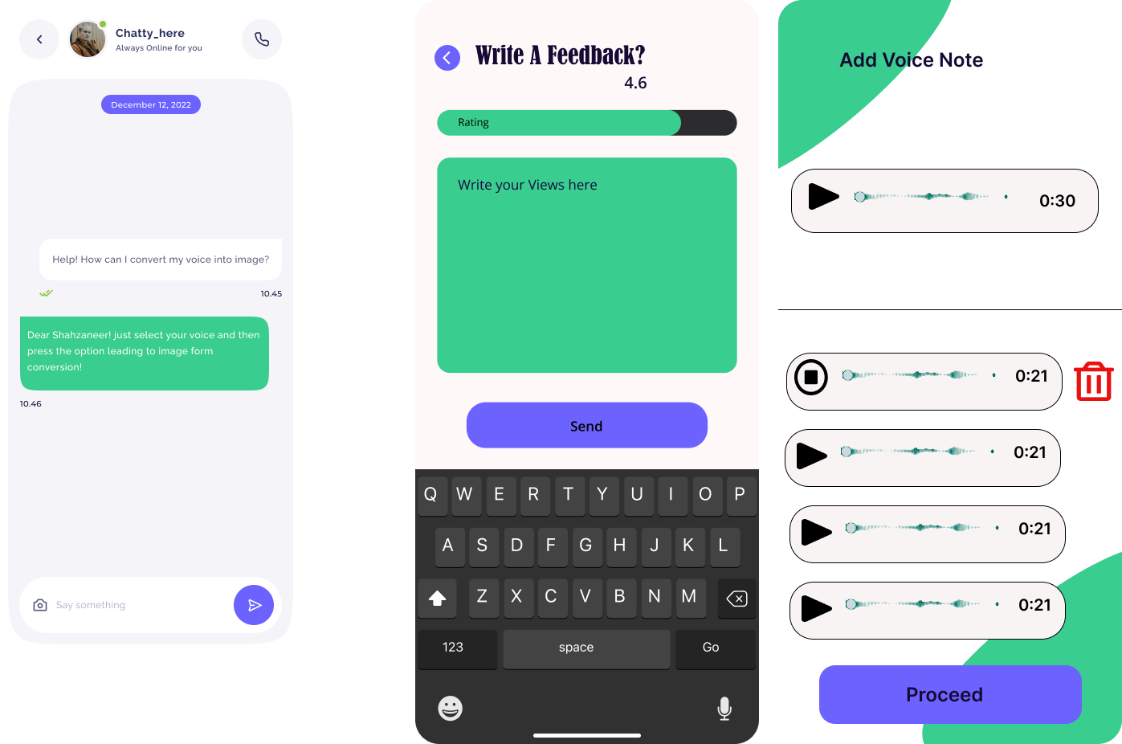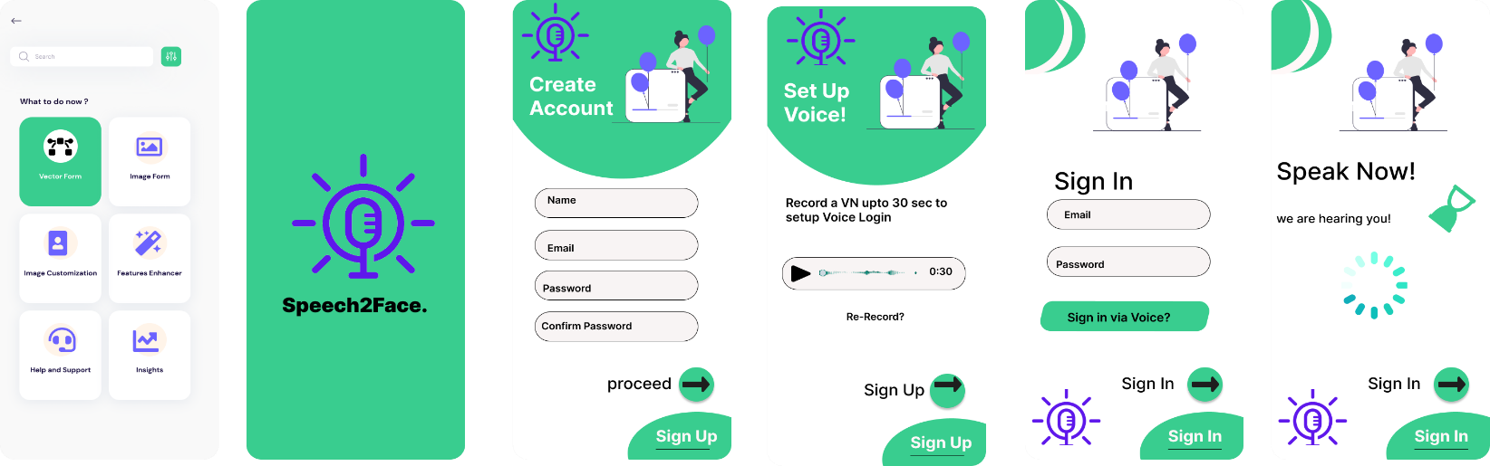

## **Software interfaces**

* + Our application is “**Speech2Face**” is an android and web-based application.
  + The application will maintain active connections with MongoDB Database version 5.0, Machine Learning Libraries and will support Flutter Dart version 3.5.
  + The software will be supported on Android 6 and above, and iOS 11 and above.
  + Our application also supports multitasking functionality and split screen functionality also available in our application.

## **Hardware interfaces**

* + - Our application automatic “**Speech2face**” also need some hardware help as well to complete its task.
    - Microphone is used in our application to input the user’s voice so that it can detect it and to process it digitally.

## **Communications interfaces**

* + - Our application “**Speech2Face**” needs active internet connection.
    - If user has downloaded something using internet, he can access that later without internet connection
    - When users send feedbacks, the application will send an email to the support team.
    - For security authentication, application will connect the user to their mobile network by sending an OTP (One Time Password) code to their phones.

# Conclusion

The SRS document portrays the final product of the project. The Functional and Non-Functional Requirements of the system are stated in detail. The document explains and quantifies Non- Functional Requirements. The document also portrays interface mockups. It is the ultimate guideline for all the stakeholders involved in the project. This SRS document is the first step into the development phase of the project**.**

# References

## Related System:

### <https://www.github.com/topics/sound-classification>.

### <https://speech2face.github.io/>

### [Google Facenet](https://www.geeksforgeeks.org/facenet-using-facial-recognition-system/%23:~:text=FaceNet%20is%20the%20name%20of,for%20Face%20Recognition%20and%20Clustering.)

## YouTube Resources:

### https://www.youtube.com/watch?v=aKYlSIs3UDY&t=334s

# SRS Work Division

|  |  |
| --- | --- |
| **Shahzaneer Ahmed**  **(SP21-BCS-087)** | **Shayan Zameer**  **(SP21-BCS-088)** |
| 1. Overall Description 2. Requirement Identifying Technique (Module 1, 3, 5, 7,9) 3. Functional Requirements   (Module 1, 3, 5, 7,9)   1. External Interface Requirements (Software & Communication interfaces) 2. Final Format Preparation of SRS Document (Word .docx file) | 1. Introduction & Conclusion 2. Requirement Identifying Technique (Module 2, 4, 6, 8) 3. Functional Requirements   (Module 2, 4, 6, 8)   1. External Interface Requirements (User interfaces & Mockups) 2. Presentation (PowerPoint .ppt file) |

# Plaragism Report

Attach the Plaragism report of your project requirement document from library staff of turnitin tool (<http://turnitin.com>)

--------------------------------------------------------------------------------------------------------------------------------------------